RAJALAKSHMI ENGINEERING COLLEGE

**RAJALAKSHMI NAGAR, THANDALAM – 602 105**



**Laboratory Record Note Book**

**CS19611**

**Mobile Application Development Laboratory**

Name : . . . . . . . . . . . . . . . . . . . . . . . . . . . . . . . . . . . . . . . . . . . . . . . . . . . . . . . . . . . . .

Year / Branch / Section : . . . . . . . . . . . . . . . . . . . . . . . . . . . . . . . . . . . . . . . . . . . . . . .

Register No. : . . . . . . . . . . . . . . . . . . . . . . . . . . . . . . . . . . . . . . . . . . . . . . . . . . . . . . . .

Semester : . . . . . . . . . . . . . . . . . . . . . . . . . . . . . . . . . . . . . . . . . . . . . . . . . . . . . . . . . .

Academic Year : . . . . . . . . . . . . . . . . . . . . . . . . . . . . . . . . . . . . . . . . . . . . . . . . . . . . .

SHARAN KUMAR D

III / CSE / D

2116220701264

VI

2024 - 2025

**4**

RAJALAKSHMI ENGINEERING COLLEGE

**RAJALAKSHMI NAGAR, THANDALAM – 602 105**

**BONAFIDE CERTIFICATE**

**Name :** SHARAN KUMAR D **Academic Year :** 2024-2025

**Semester :** VI **Branch :** Computer Science And Engineering

**Register No.**

2116220701264

*Certified that this is the bonafide record of work done by the above student in the*

MOBILE APPLICATION DEVELOPMENT LABORATORY *Laboratory during the year 2024 - 2025.*

**Signature of Faculty in-charge**

Submitted for the Practical Examination held on . . . . . . . . . . . . . . . . . . . . . . . . . . . . .

**Internal Examiner External Examiner**



**Dept. of Computer Science and Engineering** | **Rajalakshmi Engineering College**

**3**

**4**

**Dept. of Computer Science and Engineering** | **Rajalakshmi Engineering College**

**INDEX**

Reg. No. : 220701264 Name :. SHARAN KUMAR D

Year : III Branch: Computer Science and Engineering Sec: D

|  |  |  |  |  |
| --- | --- | --- | --- | --- |
| **S.**  **No.** | **Date** | **Title** | **Page No.** | **Teacher’s Signature / Remarks** |
| 1 | 20/02/2025 | GUI Components | 7 |  |
| 2 | 27/02/2025 | Simple Calculator | 12 |  |
| 3 | 04/03/2025 | Graphical Primitives | 21 |  |
| 4 | 11/03/2025 | Android Fragments | 27 |  |
| 5 | 18/03/2025 | SQLite | 36 |  |
| 6 | 18/03/2025 | Form Validation | 45 |  |
| 7 | 25/02/2025 | SD Card | 53 |  |
| 8 | 03/02/2025 | Alert Dialog Box | 58 |  |
| 9 | 12/02/2025 | Alarm | 64 |  |
| 10 | 12/02/2025 | Telephony Services | 70 |  |
| 11 | 12/02/2025 | Send SMS | 76 |  |
| 12 | 12/02/2025 | Send Email | 81 |  |
| 13 | 14/02/2025 | Text to Speech | 86 |  |
| 14 | 14/02/2025 | Speech to Text | 91 |  |
| 15 | 14/02/2025 | Image Capture | 96 |  |



**Dept. of Computer Science and Engineering** | **Rajalakshmi Engineering College**

**5**

**6**

**Dept. of Computer Science and Engineering** | **Rajalakshmi Engineering College**

**Ex. No. : 01 Date : 20/02/2025**

**Register No. : 220701264 Name : SHARAN KUMAR D**

**GUI Components**

**Aim**

Develop an application to change the font and color of the text and display toast message when the user presses the button.

**Procedure**

**Step 1:** Start

**Step 2:** Initialize the Android application using Kotlin

**Step 3:** Design the user interface

* Create a TextView to display text.
* Create a Button for user interaction.

**Step 4:** Load a custom font

* Place the .ttf font file into the res/font directory.
* Reference this font in the Kotlin code using ResourcesCompat.

**Step 5:** Link UI elements

* In onCreate(), link TextView and Button using findViewById.

**Step 6:** Set OnClickListener on the Button

* When the button is clicked:  
  + a) Change the font of the TextView using the custom font.
  + b) Change the color of the TextView text using setTextColor().
  + c) Show a Toast message indicating the changes were applied**.**

**Step 7:** End



**Dept. of Computer Science and Engineering** | **Rajalakshmi Engineering College**

**7**

**AndroidManifest.xml**

**8**

*<?***xml version="1.0" encoding="utf-8"***?>*

<**manifest xmlns:android="**[**http://schemas.android.com/apk/res/android**](http://schemas.android.com/apk/res/android)**" xmlns:tools="**[**http://schemas.android.com/tools**](http://schemas.android.com/tools)**"**>

<**application**

**android:allowBackup="true" android:dataExtractionRules="@xml/data_extraction_rules" android:fullBackupContent="@xml/backup_rules" android:icon="@mipmap/ic_launcher" android:label="@string/app_name" android:supportsRtl="true" android:theme="@style/Theme.GUIComponents" tools:targetApi="31"**>

<**activity**

**android:name=".MainActivity" android:exported="true"**>

<**intent-filter**>

<**action android:name="android.intent.action.MAIN"** />

<**category android:name="android.intent.category.LAUNCHER"** />

</**intent-filter**>

</**activity**>

</**application**>

</**manifest**>

**Dept. of Computer Science and Engineering** | **Rajalakshmi Engineering College**

**activity_main.xml**

*<?***xml version="1.0" encoding="utf-8"***?>*

<**LinearLayout xmlns:android="**[**http://schemas.android.com/apk/res/android**](http://schemas.android.com/apk/res/android)**" xmlns:app="**[**http://schemas.android.com/apk/res-auto**](http://schemas.android.com/apk/res-auto)**" xmlns:tools="**[**http://schemas.android.com/tools**](http://schemas.android.com/tools)**" android:id="@+id/linearLayout"**

**android:layout_width="match_parent" android:layout_height="match_parent" android:orientation="vertical" tools:context=".MainActivity"** >

<**TextView**

**android:id="@+id/tvText" android:layout_width="match_parent" android:layout_height="wrap_content" android:text="Rajalakshmi Engineering College" android:textAlignment="center" android:textSize="16sp"** />

<**Button**

**android:id="@+id/btFontSize" android:layout_width="match_parent" android:layout_height="wrap_content" android:inputType="textCapSentences" android:text="Change Font Size" android:textSize="16sp"** />

<**Button**

**android:id="@+id/btFontColor" android:layout_width="match_parent" android:layout_height="wrap_content" android:inputType="textCapSentences" android:text="Change Font Color" android:textSize="16sp"** />

<**Button**

**android:id="@+id/btBackgroundColor" android:layout_width="match_parent" android:layout_height="wrap_content" android:inputType="textCapSentences" android:text="Change Background Color" android:textSize="16sp"** />

</**LinearLayout**>



**Dept. of Computer Science and Engineering** | **Rajalakshmi Engineering College**

**9**

**MainActivity.kt**

**10**

**package** org.rajalakshmi.guicomponents

**import** android.graphics.Color

**import** androidx.appcompat.app.AppCompatActivity

**import** android.os.Bundle

**import** android.widget.Button **import** android.widget.LinearLayout **import** android.widget.TextView

**class** MainActivity : AppCompatActivity() {

**override fun** onCreate(savedInstanceState: Bundle?) { **super**.onCreate(savedInstanceState) setContentView(R.layout.*activity_main*)

**val** tvText : TextView = findViewById(R.id.*tvText*)

**val** btFontSize : Button = findViewById(R.id.*btFontSize*)

**val** btFontColor : Button = findViewById(R.id.*btFontColor*)

**val** btBackgroundColor : Button = findViewById(R.id.*btBackgroundColor*)

**val** linearLayout : LinearLayout = findViewById(R.id.*linearLayout*)

**var** fontSize : Float = 5f

**var** fontColor : Int = 0

**var** backgroundColor : Int = 0

btFontSize.setOnClickListener **{** tvText.setTextSize(fontSize) fontSize = (fontSize + 5) % 50

**}**

btFontColor.setOnClickListener **{ when**(fontColor % 3) {

1. -> tvText.setTextColor(Color.*RED*)
2. -> tvText.setTextColor(Color.*GREEN*)
3. -> tvText.setTextColor(Color.*BLUE*)

}

fontColor++

**}**

btBackgroundColor.setOnClickListener **{ when**(backgroundColor % 3) {

1. -> linearLayout.setBackgroundColor(Color.*RED*)
2. -> linearLayout.setBackgroundColor(Color.*GREEN*)
3. -> linearLayout.setBackgroundColor(Color.*BLUE*)

}

backgroundColor++

**}**

}

}

**Dept. of Computer Science and Engineering** | **Rajalakshmi Engineering College**

Output

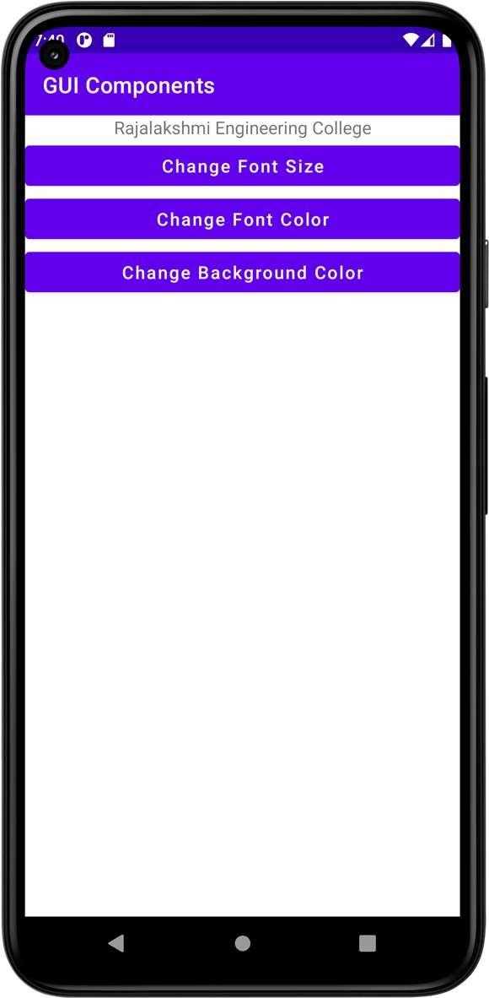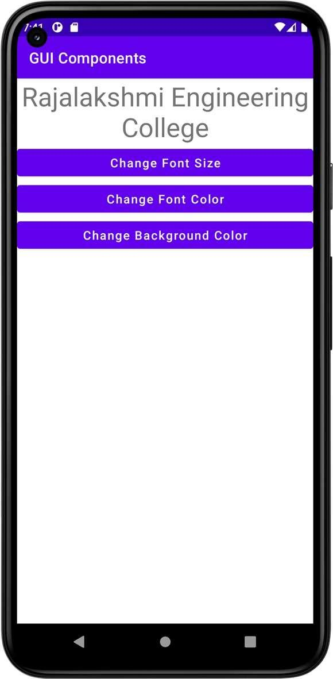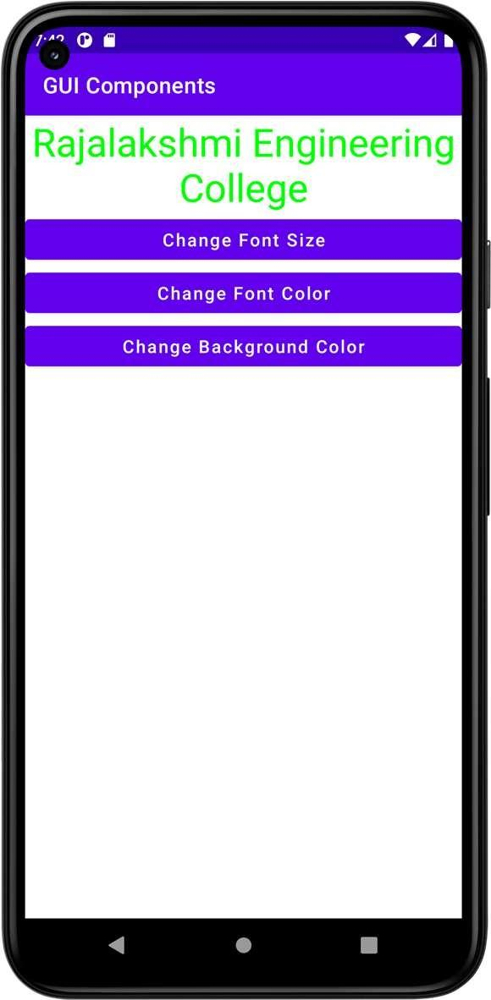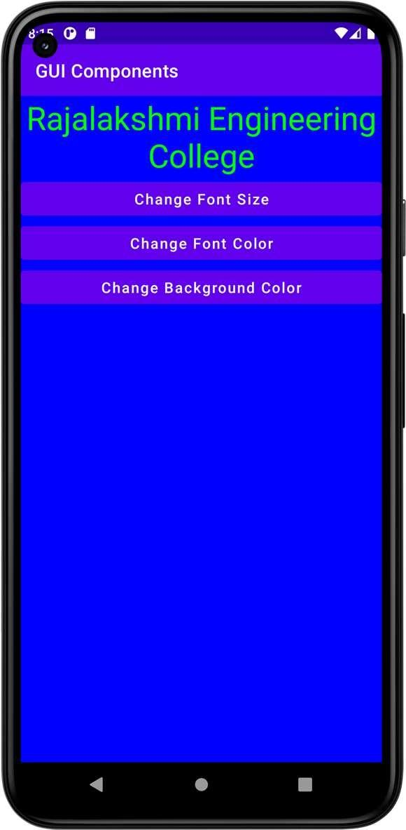

**Result**





**Dept. of Computer Science and Engineering** | **Rajalakshmi Engineering College**

**11**

**Ex. No. : 02 Date : 27/02/2025**

**12**

**Register No. : 220701264 Name : SHARAN KUMAR D**

**Simple Calculator**

**Aim**

Develop a simple calculator to perform arithmetic and mathematical functions using Math class.

**Procedure**

**Step 1:** Start

**Step 2:** Design the UI

* Create two input fields for numbers (EditText1 and EditText2)**.**
* Create buttons for operations:
  + Arithmetic: +, -, ×, ÷
  + Math functions: sqrt, pow, sin, cos, tan, etc.
* Create a TextView to display the result.

**Step 3:** Read user input

* Get number inputs from EditText1 and EditText2 (if applicable).
* Convert them from text to Double.

**Step 4:** Set up event listeners for each button

* On button click, perform the corresponding operation using Kotlin operators or Math class methods:  
  + Addition: num1 + num2
  + Subtraction: num1 - num2
  + Multiplication: num1 * num2
  + Division: num1 / num2 (check num2 != 0)

**Step 5:** Display the result

* Convert the result to a string.
* Show it in the TextView.

**Step 6:** Handle exceptions

* Validate inputs (e.g., non-empty, numeric).
* Handle divide-by-zero and invalid input formats.

**Step 7:** End

**Dept. of Computer Science and Engineering** | **Rajalakshmi Engineering College**

**AndroidManifest.xml**

*<?***xml version="1.0" encoding="utf-8"***?>*

<**manifest xmlns:android="**[**http://schemas.android.com/apk/res/android**](http://schemas.android.com/apk/res/android)**" xmlns:tools="**[**http://schemas.android.com/tools**](http://schemas.android.com/tools)**"**>

<**application**

**android:allowBackup="true" android:dataExtractionRules="@xml/data_extraction_rules" android:fullBackupContent="@xml/backup_rules" android:icon="@mipmap/ic_launcher" android:label="@string/app_name" android:supportsRtl="true" android:theme="@style/Theme.SimpleCalculator" tools:targetApi="31"**>

<**activity**

**android:name=".MainActivity" android:exported="true"**>

<**intent-filter**>

<**action android:name="android.intent.action.MAIN"** />

<**category android:name="android.intent.category.LAUNCHER"** />

</**intent-filter**>

</**activity**>

</**application**>

</**manifest**>



**Dept. of Computer Science and Engineering** | **Rajalakshmi Engineering College**

**13**

**activity_main.xml**

**14**

*<?***xml version="1.0" encoding="utf-8"***?>*

<**LinearLayout xmlns:android="**[**http://schemas.android.com/apk/res/android**](http://schemas.android.com/apk/res/android)**" xmlns:app="**[**http://schemas.android.com/apk/res-auto**](http://schemas.android.com/apk/res-auto)**" xmlns:tools="**[**http://schemas.android.com/tools**](http://schemas.android.com/tools)**" android:layout_width="match_parent" android:layout_height="match_parent"**

**android:orientation="vertical" tools:context=".MainActivity"**>

<**TextView**

**android:id="@+id/tvExpression" android:layout_width="match_parent" android:layout_height="wrap_content" android:textSize="60sp"** />

<**TextView**

**android:id="@+id/tvResult" android:layout_width="match_parent" android:layout_height="wrap_content" android:textSize="60sp"** />

<**LinearLayout**

**android:layout_width="match_parent" android:layout_height="50dp" android:orientation="horizontal"**>

<**Button**

**android:id="@+id/btSeven" android:layout_width="wrap_content" android:layout_height="wrap_content" android:layout_weight="1" android:text="7"** />

<**Button**

**android:id="@+id/btEight" android:layout_width="wrap_content" android:layout_height="wrap_content" android:layout_weight="1" android:text="8"** />

<**Button**

**android:id="@+id/btNine" android:layout_width="wrap_content" android:layout_height="wrap_content" android:layout_weight="1" android:text="9"** />

<**Button**

**android:id="@+id/btDivision" android:layout_width="wrap_content" android:layout_height="wrap_content" android:layout_weight="1" android:text="/"** />

</**LinearLayout**>

<**LinearLayout**

**android:layout_width="match_parent" android:layout_height="50dp" android:orientation="horizontal"**>

**Dept. of Computer Science and Engineering** | **Rajalakshmi Engineering College**

****<**Button**

**android:id="@+id/btFour" android:layout_width="wrap_content" android:layout_height="wrap_content" android:layout_weight="1" android:text="4"** />

<**Button**

**android:id="@+id/btFive" android:layout_width="wrap_content" android:layout_height="wrap_content" android:layout_weight="1" android:text="5"** />

<**Button**

**android:id="@+id/btSix" android:layout_width="wrap_content" android:layout_height="wrap_content" android:layout_weight="1" android:text="6"** />

<**Button**

**android:id="@+id/btMultiplication" android:layout_width="wrap_content" android:layout_height="wrap_content" android:layout_weight="1" android:text="X"** />

</**LinearLayout**>

<**LinearLayout**

**android:layout_width="match_parent" android:layout_height="50dp" android:orientation="horizontal"**>

<**Button**

**android:id="@+id/btOne" android:layout_width="wrap_content" android:layout_height="wrap_content" android:layout_weight="1" android:text="1"** />

<**Button**

**android:id="@+id/btTwo" android:layout_width="wrap_content" android:layout_height="wrap_content" android:layout_weight="1" android:text="2"** />

<**Button**

**android:id="@+id/btThree" android:layout_width="wrap_content" android:layout_height="wrap_content" android:layout_weight="1" android:text="3"** />

<**Button**

**android:id="@+id/btSubtraction" android:layout_width="wrap_content" android:layout_height="wrap_content" android:layout_weight="1" android:text="-"** />



**Dept. of Computer Science and Engineering** | **Rajalakshmi Engineering College**

**15**

</**LinearLayout**>

**16**

<**LinearLayout**

**android:layout_width="match_parent" android:layout_height="50dp" android:orientation="horizontal"**>

<**Button**

**android:id="@+id/btDecimal" android:layout_width="wrap_content" android:layout_height="wrap_content" android:layout_weight="1" android:text="."** />

<**Button**

**android:id="@+id/btZero" android:layout_width="wrap_content" android:layout_height="wrap_content" android:layout_weight="1" android:text="0"** />

<**Button**

**android:id="@+id/btEqual" android:layout_width="wrap_content" android:layout_height="wrap_content" android:layout_weight="1" android:text="="** />

<**Button**

**android:id="@+id/btAddition" android:layout_width="wrap_content" android:layout_height="wrap_content" android:layout_weight="1" android:text="+"** />

</**LinearLayout**>

<**Button**

**android:id="@+id/btClear" android:layout_width="match_parent" android:layout_height="wrap_content" android:text="Clear" android:textAllCaps="false"** />

</**LinearLayout**>

**Dept. of Computer Science and Engineering** | **Rajalakshmi Engineering College**

**MainActivity.xml**

**package** org.rajalakshmi.simplecalculator

**import** androidx.appcompat.app.AppCompatActivity

**import** android.os.Bundle **import** android.widget.Button **import** android.widget.TextView

**class** MainActivity : AppCompatActivity() {

**var input1** :Double = 0.0

**var input2** :Double = 0.0

**var addition** : Boolean = **false var subtraction** : Boolean = **false**

**var multiplication** : Boolean = **false var division** : Boolean = **false**

**var decimal** : Boolean = **false**

**override fun** onCreate(savedInstanceState: Bundle?) { **super**.onCreate(savedInstanceState) setContentView(R.layout.*activity_main*)

**val** tvExpression : TextView = findViewById(R.id.*tvExpression*)

**val** tvResult : TextView = findViewById(R.id.*tvResult*)

**val** btZero : Button = findViewById(R.id.*btZero*) **val** btOne : Button = findViewById(R.id.*btOne*) **val** btTwo : Button = findViewById(R.id.*btTwo*)

**val** btThree : Button = findViewById(R.id.*btThree*) **val** btFour : Button = findViewById(R.id.*btFour*) **val** btFive : Button = findViewById(R.id.*btFive*) **val** btSix : Button = findViewById(R.id.*btSix*)

**val** btSeven : Button = findViewById(R.id.*btSeven*) **val** btEight : Button = findViewById(R.id.*btEight*) **val** btNine : Button = findViewById(R.id.*btNine*)

**val** btAddition : Button = findViewById(R.id.*btAddition*)

**val** btSubtraction : Button = findViewById(R.id.*btSubtraction*)

**val** btMultiplication : Button = findViewById(R.id.*btMultiplication*)

**val** btDivision : Button = findViewById(R.id.*btDivision*) **val** btDecimal : Button = findViewById(R.id.*btDecimal*) **val** btEqual : Button = findViewById(R.id.*btEqual*)

**val** btClear : Button = findViewById(R.id.*btClear*)

btZero.setOnClickListener **{**

tvExpression.setText(**"${**tvExpression.*text***}0"**)

**}**

btOne.setOnClickListener **{**

tvExpression.setText(**"${**tvExpression.*text***}1"**)

**}**

btTwo.setOnClickListener **{**

tvExpression.setText(**"${**tvExpression.*text***}2"**)

**}**

btThree.setOnClickListener **{**

tvExpression.setText(**"${**tvExpression.*text***}3"**)

**}**

btFour.setOnClickListener **{**

tvExpression.setText(**"${**tvExpression.*text***}4"**)

**}**

btFive.setOnClickListener **{**

tvExpression.setText(**"${**tvExpression.*text***}5"**)

**}**

btSix.setOnClickListener **{**

tvExpression.setText(**"${**tvExpression.*text***}6"**)



**Dept. of Computer Science and Engineering** | **Rajalakshmi Engineering College**

**17**

**}**

**18**

btSeven.setOnClickListener **{**

tvExpression.setText(**"${**tvExpression.*text***}7"**)

**}**

btEight.setOnClickListener **{**

tvExpression.setText(**"${**tvExpression.*text***}8"**)

**}**

btNine.setOnClickListener **{**

tvExpression.setText(**"${**tvExpression.*text***}9"**)

**}**

btDecimal.setOnClickListener **{ if**(!**decimal**) {

tvExpression.setText(**"${**tvExpression.*text***}."**)

**decimal** = **true**

}

**}**

btAddition.setOnClickListener **{**

**if** (tvExpression.getText().**length** != 0) { **input1** = **"${**tvExpression.*text***}"**.*toDouble*() **addition** = **true**

**decimal** = **false**

tvExpression.setText(**null**)

}

**}**

btSubtraction.setOnClickListener **{**

**if** (tvExpression.getText().**length** != 0) { **input1** = **"${**tvExpression.*text***}"**.*toDouble*() **subtraction** = **true**

**decimal** = **false**

tvExpression.setText(**null**)

}

**}**

btMultiplication.setOnClickListener **{**

**if** (tvExpression.getText().**length** != 0) { **input1** = **"${**tvExpression.*text***}"**.*toDouble*() **multiplication** = **true**

**decimal** = **false**

tvExpression.setText(**null**)

}

**}**

btDivision.setOnClickListener **{**

**if** (tvExpression.getText().**length** != 0) { **input1** = **"${**tvExpression.*text***}"**.*toDouble*() **division** = **true**

**decimal** = **false**

tvExpression.setText(**null**)

}

**}**

btEqual.setOnClickListener() **{**

**input2** = **"${**tvExpression.*text***}"**.*toDouble*() **if** (**addition**) {

tvExpression.setText(**"${input1} + ${input2}"**) **val** raddition : Double = **input1** + **input2** tvResult.setText(**"${**raddition**}"**)

**addition** = **false**

}

**if** (**subtraction**) { tvExpression.setText(**"${input1} - ${input2}"**) **val** rsubtraction : Double = **input1** - **input2** tvResult.setText(**"${**rsubtraction**}"**) **subtraction** = **false**

}

**Dept. of Computer Science and Engineering** | **Rajalakshmi Engineering College**

**if** (**multiplication**) { tvExpression.setText(**"${input1} * ${input2}"**) **val** rmultiplication : Double = **input1** * **input2** tvResult.setText(**"${**rmultiplication**}"**) **multiplication** = **false**

}

**if** (**division**) {

tvExpression.setText(**"${input1} / ${input2}"**) **val** rdivision : Double = **input1** / **input2** tvResult.setText(**"${**rdivision**}"**)

**division** = **false**

}

**}**

btClear.setOnClickListener **{** tvExpression.setText(**""**) tvResult.setText(**""**) **input1** = 0.0

**input2** = 0.0

**decimal** = **false**

**}**

}

}



**Dept. of Computer Science and Engineering** | **Rajalakshmi Engineering College**

**19**

**Output**

**20**

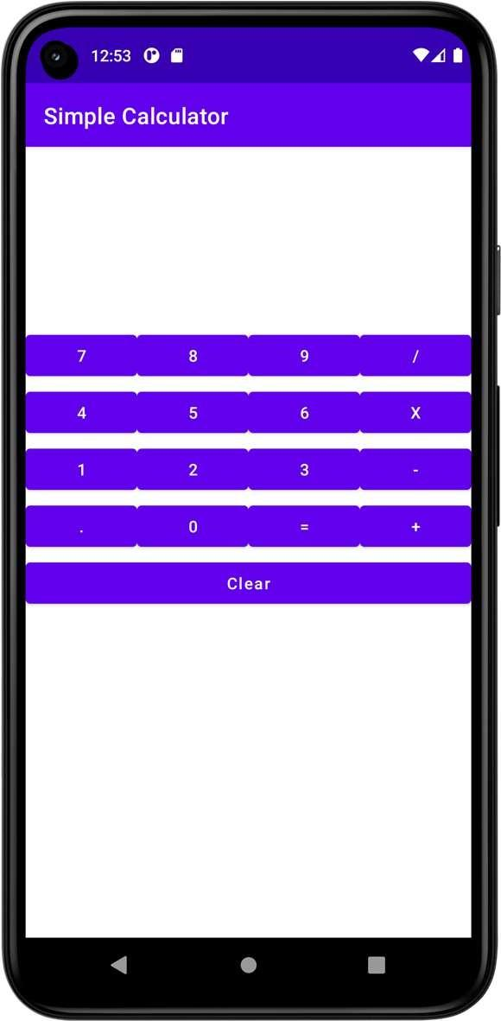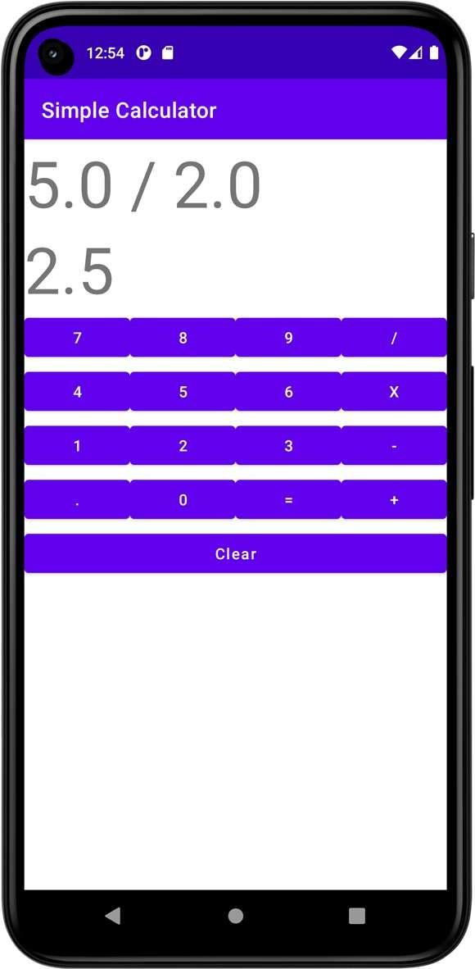

**Dept. of Computer Science and Engineering** | **Rajalakshmi Engineering College**

**Ex. No. : 03 Date : 04/03/2025**

**Register No. : 220701264 Name : SHARAN KUMAR D**

**Graphical Primitives**

**Aim**

Develop an android application to draw the circle, ellipse, rectangle and some text using Android Graphical primitives.

**Procedure**

**Step 1:** Create a New Android Project

* Open Android Studio.
* Select "New Project" > "Empty Activity."
* Name the project (e.g., DrawShapesApp) and choose Kotlin/Java as the language.

**Step 2:** Create a Custom View for Drawing Shapes

* In the src folder, create a new Kotlin file: CustomView.kt.
* In this file, create a class that extends View to draw shapes using Canvas.

**Step 3:** Override onDraw Method

* Use the Canvas object to draw the circle, ellipse, rectangle, and text using methods like drawCircle(), drawOval(), drawRect(), and drawText().

**Step 6:** Update the MainActivity

* Set the custom view as the content view in MainActivity.

**Step 5:** Run the App

* Build and run the app to see the shapes and text drawn on the screen



**Dept. of Computer Science and Engineering** | **Rajalakshmi Engineering College**

**21**

**AndroidManifest.xml**

**22**

*<?***xml version="1.0" encoding="utf-8"***?>*

<**manifest xmlns:android="**[**http://schemas.android.com/apk/res/android**](http://schemas.android.com/apk/res/android)**" xmlns:tools="**[**http://schemas.android.com/tools**](http://schemas.android.com/tools)**"**>

<**application**

**android:allowBackup="true" android:dataExtractionRules="@xml/data_extraction_rules" android:fullBackupContent="@xml/backup_rules" android:icon="@mipmap/ic_launcher" android:label="@string/app_name" android:supportsRtl="true" android:theme="@style/Theme.GraphicalPrimitives" tools:targetApi="31"**>

<**activity**

**android:name=".MainActivity" android:exported="true"**>

<**intent-filter**>

<**action android:name="android.intent.action.MAIN"** />

<**category android:name="android.intent.category.LAUNCHER"** />

</**intent-filter**>

</**activity**>

</**application**>

</**manifest**>

**Dept. of Computer Science and Engineering** | **Rajalakshmi Engineering College**

**activity_main.xml**

*<?***xml version="1.0" encoding="utf-8"***?>*

<**androidx.constraintlayout.widget.ConstraintLayout xmlns:android="**[**http://schemas.android.com/apk/res/android**](http://schemas.android.com/apk/res/android)**"**

**xmlns:app="**[**http://schemas.android.com/apk/res-auto**](http://schemas.android.com/apk/res-auto)**" xmlns:tools="**[**http://schemas.android.com/tools**](http://schemas.android.com/tools)**" android:layout_width="match_parent" android:layout_height="match_parent" tools:context=".MainActivity"**>

<**org.rajalakshmi.graphicalprimitives.SampleCanvas android:layout_width="match_parent" android:layout_height="match_parent"**>

</**org.rajalakshmi.graphicalprimitives.SampleCanvas**>

</**androidx.constraintlayout.widget.ConstraintLayout**>



**Dept. of Computer Science and Engineering** | **Rajalakshmi Engineering College**

**23**

**MainActivity.kt**

**24**

**package** org.rajalakshmi.graphicalprimitives

**import** androidx.appcompat.app.AppCompatActivity

**import** android.os.Bundle

**class** MainActivity : AppCompatActivity() {

**override fun** onCreate(savedInstanceState: Bundle?) { **super**.onCreate(savedInstanceState) setContentView(R.layout.*activity_main*)

}

}

**Dept. of Computer Science and Engineering** | **Rajalakshmi Engineering College**

**SampleCanvas.kt**

**package** org.rajalakshmi.graphicalprimitives

**import** android.content.Context **import** android.graphics.Canvas **import** android.graphics.Color **import** android.graphics.Paint **import** android.util.AttributeSet **import** android.view.View

**class** SampleCanvas @JvmOverloads **constructor**(

context: Context, attrs: AttributeSet? = **null**, defStyleAttr: Int = 0

) : View(context, attrs, defStyleAttr) {

**override fun** onDraw(canvas: Canvas?) {

**super**.onDraw(canvas)

**val** paint : Paint = Paint() paint.setColor(Color.*YELLOW*) canvas?.drawPaint(paint) paint.setTextSize(50f); paint.setColor(Color.*RED*); canvas?.drawText(**"Circle"**, 120f, 150f, paint); canvas?.drawCircle(200f, 350f, 150f, paint); paint.setColor(Color.*GREEN*);

canvas?.drawText(**"Rectangle"**, 420f, 150f, paint); canvas?.drawRect(400f, 200f, 650f, 700f, paint); paint.setColor(Color.*BLUE*); canvas?.drawText(**"Square"**, 120f, 800f, paint); canvas?.drawRect(50f, 850f, 350f, 1150f, paint); paint.setColor(Color.*BLACK*); canvas?.drawText(**"Line"**, 480f, 800f, paint); canvas?.drawLine(520f, 850f, 520f, 1150f, paint);

}

}



**Dept. of Computer Science and Engineering** | **Rajalakshmi Engineering College**

**25**

**Output**

**26**

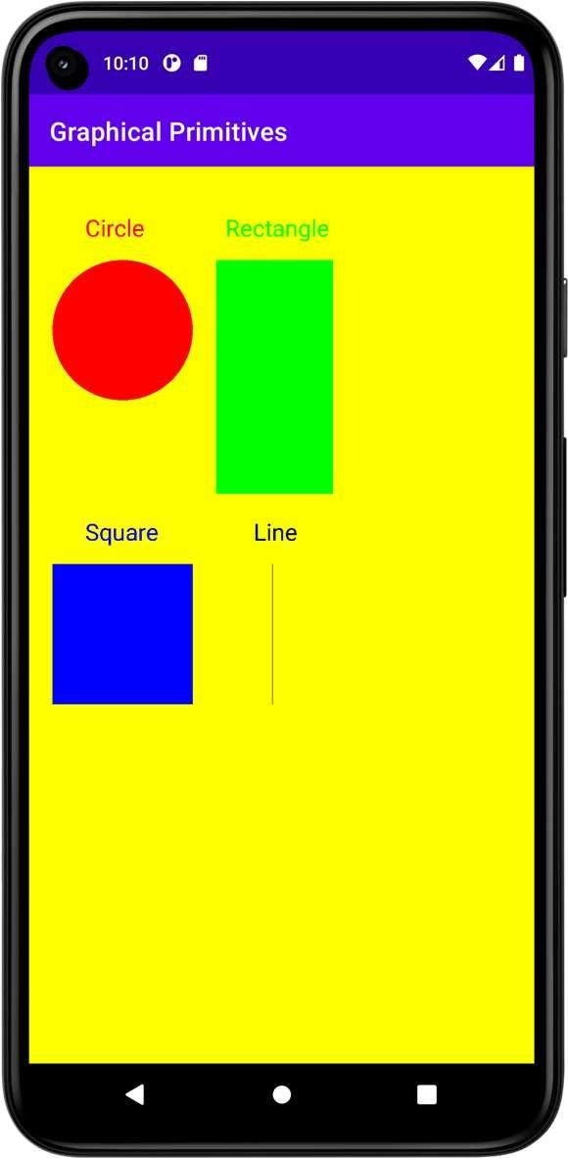

**Result**



**Dept. of Computer Science and Engineering** | **Rajalakshmi Engineering College**

**Ex. No. : 04 Date : 11/03/2025**

**Register No. : 220701264 Name : SHARAN KUMAR D**

**Android Fragments**

**Aim**

Develop an android application to create two activities named as Student Basic Details (Register No., Name, Department) and Student Mark Details (SSLC, HSC, UG). Write an android code to combine these two activities in single screen using android fragment.

**Procedure**



**Step 1:** Create a New Android Project:

* Open Android Studio and create a new project.
* Select "Empty Activity" and name it (e.g., StudentDetailsApp).
* Choose Kotlin as the programming language.

**Step 2:** Create Two Fragments:

* One fragment for Student Basic Details.
* One fragment for Student Mark Details.

**Step 3:** Create a Layout for Each Fragment:

* The first fragment will contain fields for Register Number, Name, and Department.
* The second fragment will contain fields for SSLC, HSC, and UG marks.

**Step 4:** Combine the Fragments in the Main Activity:

* Use FragmentTransaction to display both fragments in a single activity



**Dept. of Computer Science and Engineering** | **Rajalakshmi Engineering College**

**27**

**AndroidManifest.xml**

**28**

*<?***xml version="1.0" encoding="utf-8"***?>*

<**manifest xmlns:android="**[**http://schemas.android.com/apk/res/android**](http://schemas.android.com/apk/res/android)**" xmlns:tools="**[**http://schemas.android.com/tools**](http://schemas.android.com/tools)**"**>

<**application**

**android:allowBackup="true" android:dataExtractionRules="@xml/data_extraction_rules" android:fullBackupContent="@xml/backup_rules" android:icon="@mipmap/ic_launcher" android:label="@string/app_name" android:supportsRtl="true" android:theme="@style/Theme.AndroidFragments" tools:targetApi="31"**>

<**activity**

**android:name=".MainActivity" android:exported="true"**>

<**intent-filter**>

<**action android:name="android.intent.action.MAIN"** />

<**category android:name="android.intent.category.LAUNCHER"** />

</**intent-filter**>

</**activity**>

</**application**>

</**manifest**>

**Dept. of Computer Science and Engineering** | **Rajalakshmi Engineering College**

**activity_main.xml**

*<?***xml version="1.0" encoding="utf-8"***?>*

<**LinearLayout xmlns:android="**[**http://schemas.android.com/apk/res/android**](http://schemas.android.com/apk/res/android)**" xmlns:app="**[**http://schemas.android.com/apk/res-auto**](http://schemas.android.com/apk/res-auto)**" xmlns:tools="**[**http://schemas.android.com/tools**](http://schemas.android.com/tools)**" android:layout_width="match_parent" android:layout_height="match_parent"**

**android:orientation="vertical" tools:context=".MainActivity"**>

<**TextView**

**android:id="@+id/tvTitle" android:layout_width="match_parent" android:layout_height="wrap_content" android:text="Student Details" android:textAlignment="center" android:textSize="24sp"** />

<**LinearLayout**

**android:layout_width="match_parent" android:layout_height="match_parent" android:orientation="vertical"**>

<**fragment**

**android:id="@+id/fragmentBasic" android:name="org.rajalakshmi.androidfragments.StudentBasicDetails" android:layout_width="match_parent"**

**android:layout_height="300dp"** />

<**fragment**

**android:id="@+id/fragmentMark" android:name="org.rajalakshmi.androidfragments.StudentMarkDetails" android:layout_width="match_parent"**

**android:layout_height="300dp"** />

</**LinearLayout**>

</**LinearLayout**>



**Dept. of Computer Science and Engineering** | **Rajalakshmi Engineering College**

**29**

**fragment_student_basic_details.xml**

**30**

*<?***xml version="1.0" encoding="utf-8"***?>*

<**FrameLayout xmlns:android="**[**http://schemas.android.com/apk/res/android**](http://schemas.android.com/apk/res/android)**" xmlns:tools="**[**http://schemas.android.com/tools**](http://schemas.android.com/tools)**" android:layout_width="match_parent" android:layout_height="match_parent" tools:context=".StudentBasicDetails"**>

<**TextView**

**android:id="@+id/tvBasicDetails" android:layout_width="match_parent" android:layout_height="wrap_content" android:text="Basic Details" android:textAlignment="center" android:textSize="24sp"** />

<**TextView**

**android:id="@+id/tvRegisterNumber" android:layout_width="wrap_content" android:layout_height="wrap_content" android:layout_marginTop="50dp" android:text="Register No."** />

<**EditText**

**android:id="@+id/etRegisterNumber" android:layout_width="wrap_content" android:layout_height="wrap_content" android:layout_marginLeft="150dp" android:layout_marginTop="50dp" android:ems="10" android:hint="Register Number" android:inputType="textPersonName"** />

<**TextView**

**android:id="@+id/tvName" android:layout_width="wrap_content" android:layout_height="wrap_content" android:layout_marginTop="125dp" android:text="Name"** />

<**EditText**

**android:id="@+id/etName" android:layout_width="wrap_content" android:layout_height="wrap_content" android:layout_marginLeft="150dp" android:layout_marginTop="125dp" android:ems="10"**

**android:hint="Name" android:inputType="textPersonName"** />

<**TextView**

**android:id="@+id/tvDepartment" android:layout_width="wrap_content" android:layout_height="wrap_content" android:layout_marginTop="200dp" android:text="Department"** />

<**EditText**

**android:id="@+id/etDepartment" android:layout_width="wrap_content" android:layout_height="wrap_content" android:layout_marginLeft="150dp" android:layout_marginTop="200dp" android:ems="10" android:hint="Department" android:inputType="textPersonName"** />

</**FrameLayout**>

**Dept. of Computer Science and Engineering** | **Rajalakshmi Engineering College**

**fragment_student_mark_details.xml**

*<?***xml version="1.0" encoding="utf-8"***?>*

<**FrameLayout xmlns:android="**[**http://schemas.android.com/apk/res/android**](http://schemas.android.com/apk/res/android)**" xmlns:tools="**[**http://schemas.android.com/tools**](http://schemas.android.com/tools)**" android:layout_width="match_parent" android:layout_height="match_parent" tools:context=".StudentMarkDetails"**>

<**TextView**

**android:id="@+id/tvBasicDetails" android:layout_width="match_parent" android:layout_height="wrap_content" android:text="Mark Details" android:textAlignment="center" android:textSize="24sp"** />

<**TextView**

**android:id="@+id/tvSSLC" android:layout_width="wrap_content" android:layout_height="wrap_content" android:layout_marginTop="50dp" android:text="S.S.L.C."** />

<**EditText**

**android:id="@+id/etSSLC" android:layout_width="wrap_content" android:layout_height="wrap_content" android:layout_marginLeft="150dp" android:layout_marginTop="50dp" android:ems="10" android:hint="S.S.L.C. Mark" android:inputType="textPersonName"** />

<**TextView**

**android:id="@+id/tvHSc" android:layout_width="wrap_content" android:layout_height="wrap_content" android:layout_marginTop="125dp" android:text="H.Sc."** />

<**EditText**

**android:id="@+id/etHSC" android:layout_width="wrap_content" android:layout_height="wrap_content" android:layout_marginLeft="150dp" android:layout_marginTop="125dp" android:ems="10"**

**android:hint="H.Sc. Mark" android:inputType="textPersonName"** />

<**TextView**

**android:id="@+id/tvUG" android:layout_width="wrap_content" android:layout_height="wrap_content" android:layout_marginTop="200dp" android:text="U.G."** />

<**EditText**

**android:id="@+id/etUG" android:layout_width="wrap_content" android:layout_height="wrap_content" android:layout_marginLeft="150dp" android:layout_marginTop="200dp" android:ems="10"**

**android:hint="U.G. C.G.P.A." android:inputType="textPersonName"** />

</**FrameLayout**>



**Dept. of Computer Science and Engineering** | **Rajalakshmi Engineering College**

**31**

**MainActivity.kt**

**32**

**package** org.rajalakshmi.androidfragments

**import** androidx.appcompat.app.AppCompatActivity

**import** android.os.Bundle

**class** MainActivity : AppCompatActivity() {

**override fun** onCreate(savedInstanceState: Bundle?) { **super**.onCreate(savedInstanceState) setContentView(R.layout.*activity_main*)

}

}

**Dept. of Computer Science and Engineering** | **Rajalakshmi Engineering College**

**StudentBasicDetails.kt**

**package** org.rajalakshmi.androidfragments

**import** android.os.Bundle

**import** androidx.fragment.app.Fragment **import** android.view.LayoutInflater **import** android.view.View

**import** android.view.ViewGroup

*//* ***TODO: Rename parameter arguments, choose names that match***

*// the fragment initialization parameters, e.g. ARG_ITEM_NUMBER*

**private const val** *ARG_PARAM1* = **"param1" private const val** *ARG_PARAM2* = **"param2"**

*/\*\**

*\* A simple* ***[Fragment]*** *subclass.*

*\* Use the* ***[StudentBasicDetails.newInstance]*** *factory method to*

*\* create an instance of this fragment.*

*\*/*

**class** StudentBasicDetails : Fragment() {

*//* ***TODO: Rename and change types of parameters***

**private var param1**: String? = **null private var param2**: String? = **null**

**override fun** onCreate(savedInstanceState: Bundle?) { **super**.onCreate(savedInstanceState) *arguments*?.*let* **{**

**param1** = **it**.getString(*ARG_PARAM1*) **param2** = **it**.getString(*ARG_PARAM2*)

**}**

}

**override fun** onCreateView(

inflater: LayoutInflater, container: ViewGroup?, savedInstanceState: Bundle?

): View? {

*// Inflate the layout for this fragment*

**return** inflater.inflate(R.layout.*fragment_student_basic_details*, container, **false**)

}

**companion object** {

*/\*\**

*\* Use this factory method to create a new instance of*

*\* this fragment using the provided parameters.*

*\**

*\** ***@param param1*** *Parameter 1.*

*\** ***@param param2*** *Parameter 2.*

*\** ***@return*** *A new instance of fragment StudentBasicDetails.*

*\*/*

*//* ***TODO: Rename and change types and number of parameters***

@JvmStatic

**fun** newInstance(param1: String, param2: String) = StudentBasicDetails().*apply* **{**

*arguments* = Bundle().*apply* **{** putString(*ARG_PARAM1*, param1) putString(*ARG_PARAM2*, param2)

**}**

**}**

}

}



**Dept. of Computer Science and Engineering** | **Rajalakshmi Engineering College**

**33**

**StudentMarkDetails.kt**

**34**

**package** org.rajalakshmi.androidfragments

**import** android.os.Bundle

**import** androidx.fragment.app.Fragment **import** android.view.LayoutInflater **import** android.view.View

**import** android.view.ViewGroup

*//* ***TODO: Rename parameter arguments, choose names that match***

*// the fragment initialization parameters, e.g. ARG_ITEM_NUMBER*

**private const val** *ARG_PARAM1* = **"param1" private const val** *ARG_PARAM2* = **"param2"**

*/\*\**

*\* A simple* ***[Fragment]*** *subclass.*

*\* Use the* ***[StudentMarkDetails.newInstance]*** *factory method to*

*\* create an instance of this fragment.*

*\*/*

**class** StudentMarkDetails : Fragment() {

*//* ***TODO: Rename and change types of parameters***

**private var param1**: String? = **null private var param2**: String? = **null**

**override fun** onCreate(savedInstanceState: Bundle?) { **super**.onCreate(savedInstanceState) *arguments*?.*let* **{**

**param1** = **it**.getString(*ARG_PARAM1*) **param2** = **it**.getString(*ARG_PARAM2*)

**}**

}

**override fun** onCreateView(

inflater: LayoutInflater, container: ViewGroup?, savedInstanceState: Bundle?

): View? {

*// Inflate the layout for this fragment*

**return** inflater.inflate(R.layout.*fragment_student_mark_details*, container, **false**)

}

**companion object** {

*/\*\**

*\* Use this factory method to create a new instance of*

*\* this fragment using the provided parameters.*

*\**

*\** ***@param param1*** *Parameter 1.*

*\** ***@param param2*** *Parameter 2.*

*\** ***@return*** *A new instance of fragment StudentMarkDetails.*

*\*/*

*//* ***TODO: Rename and change types and number of parameters***

@JvmStatic

**fun** newInstance(param1: String, param2: String) = StudentMarkDetails().*apply* **{**

*arguments* = Bundle().*apply* **{** putString(*ARG_PARAM1*, param1) putString(*ARG_PARAM2*, param2)

**}**

**}**

}

}

**Dept. of Computer Science and Engineering** | **Rajalakshmi Engineering College**

**Output**

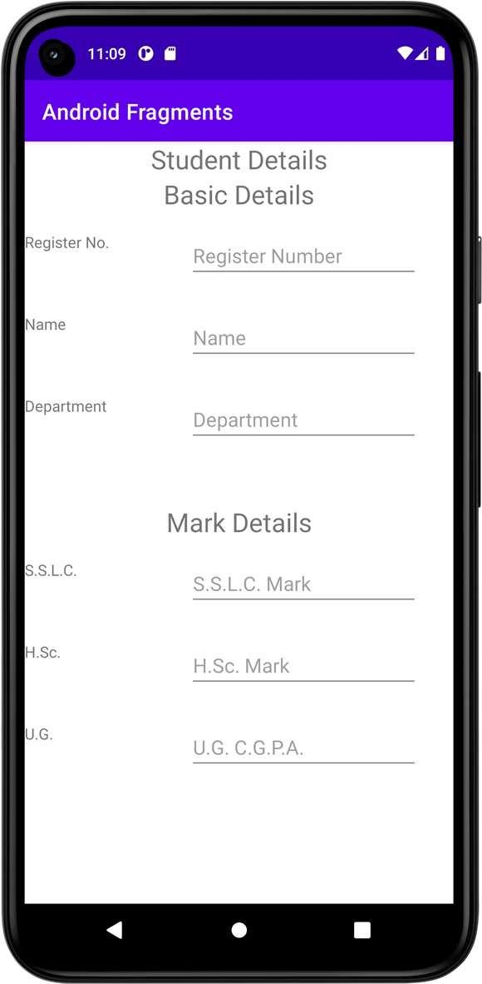

**Result**





**Dept. of Computer Science and Engineering** | **Rajalakshmi Engineering College**

**35**

|  |  |  |
| --- | --- | --- |
| **Ex. No. :**  **Register No. : 220701264** | **05** | **Date : 18/03/2025**  **Name : SHARAN KUMAR D** |
| **Aim** |  | **SQLite** |

**36**

Create a Database table with the following structure using SQLite: Student (Register Number, Name, CGPA). Develop an android application to perform the following operation using SQLite developer classes. 1. Insert student Details 2. Update the student Record 3. Delete a specified record. 4. View the details.

**Procedure**

**Step 1**: Create a new Android project in Android Studio.

**Step 2:** Design the layout with input fields for Register Number, Name, and CGPA, along with buttons for Insert, Update, Delete, and View.

**Step 3**: Create a custom SQLiteOpenHelper class to define the Student table and override the necessary methods for database creation and upgrade.

**Step 4**: In the MainActivity, handle each button click to perform the corresponding database operation (insert, update, delete, or retrieve data).

**Step 5:** Display the retrieved student details in a TextView or using a ListView/RecyclerView.

**Dept. of Computer Science and Engineering** | **Rajalakshmi Engineering College**

**AndroidManifest.xml**

*<?***xml version="1.0" encoding="utf-8"***?>*

<**manifest xmlns:android="**[**http://schemas.android.com/apk/res/android**](http://schemas.android.com/apk/res/android)**" xmlns:tools="**[**http://schemas.android.com/tools**](http://schemas.android.com/tools)**"**>

<**application**

**android:allowBackup="true" android:dataExtractionRules="@xml/data_extraction_rules" android:fullBackupContent="@xml/backup_rules" android:icon="@mipmap/ic_launcher" android:label="@string/app_name" android:supportsRtl="true" android:theme="@style/Theme.SQLite" tools:targetApi="31"**>

<**activity**

**android:name=".MainActivity" android:exported="true"**>

<**intent-filter**>

<**action android:name="android.intent.action.MAIN"** />

<**category android:name="android.intent.category.LAUNCHER"** />

</**intent-filter**>

</**activity**>

</**application**>

</**manifest**>



**Dept. of Computer Science and Engineering** | **Rajalakshmi Engineering College**

**37**

**activity_main.xml**

**38**

*<?***xml version="1.0" encoding="utf-8"***?>*

<**LinearLayout xmlns:android="**[**http://schemas.android.com/apk/res/android**](http://schemas.android.com/apk/res/android)**" xmlns:app="**[**http://schemas.android.com/apk/res-auto**](http://schemas.android.com/apk/res-auto)**" xmlns:tools="**[**http://schemas.android.com/tools**](http://schemas.android.com/tools)**" android:layout_width="match_parent" android:layout_height="match_parent"**

**android:orientation="vertical" tools:context=".MainActivity"** >

<**TextView**

**android:id="@+id/tvRegisterNumber" android:layout_width="match_parent" android:layout_height="wrap_content" android:text="Register Number"** />

<**EditText**

**android:id="@+id/etRegisterNumber" android:layout_width="match_parent" android:layout_height="wrap_content" android:ems="10" android:inputType="textPersonName"** />

<**TextView**

**android:id="@+id/tvName" android:layout_width="match_parent" android:layout_height="wrap_content" android:text="Name"** />

<**EditText**

**android:id="@+id/etName" android:layout_width="match_parent" android:layout_height="wrap_content" android:ems="10" android:inputType="textPersonName"** />

<**TextView**

**android:id="@+id/tvCGPA" android:layout_width="match_parent" android:layout_height="wrap_content" android:text="CGPA"** />

<**EditText**

**android:id="@+id/etCGPA" android:layout_width="match_parent" android:layout_height="wrap_content" android:ems="10" android:inputType="textPersonName"** />

<**Button**

**android:id="@+id/btAdd" android:layout_width="match_parent" android:layout_height="wrap_content" android:text="Add" android:textAllCaps="false"** />

<**Button**

**android:id="@+id/btView" android:layout_width="match_parent" android:layout_height="wrap_content"**

**Dept. of Computer Science and Engineering** | **Rajalakshmi Engineering College**

**android:text="View" android:textAllCaps="false"** />

<**Button**

**android:id="@+id/btModify" android:layout_width="match_parent" android:layout_height="wrap_content" android:text="Modify" android:textAllCaps="false"** />

<**Button**

**android:id="@+id/btDelete" android:layout_width="match_parent" android:layout_height="wrap_content" android:text="Delete" android:textAllCaps="false"** />

<**Button**

**android:id="@+id/btClear" android:layout_width="match_parent" android:layout_height="wrap_content" android:text="Clear" android:textAllCaps="false"** />

</**LinearLayout**>



**Dept. of Computer Science and Engineering** | **Rajalakshmi Engineering College**

**39**

**DBContract.kt**

**40**

**package** org.rajalakshmi.sqlite

**import** android.provider.BaseColumns

**object** DBContract {

**class** UserEntry : BaseColumns {

**companion object** {

**val TABLE_NAME** = **"students"**

**val COLUMN_REGISTER_NUMBER** = **"registernumber" val COLUMN_NAME** = **"name"**

**val COLUMN_CGPA** = **"cgpa"**

}

}

}

**UserModel.kt**

**package** org.rajalakshmi.sqlite

**class** UserModel (**val registernumber** : String, **val name** : String, **val cgpa** : String)

**Dept. of Computer Science and Engineering** | **Rajalakshmi Engineering College**

**UsersDBHelper.kt**

**package** org.rajalakshmi.sqlite

**import** android.annotation.SuppressLint **import** android.content.ContentValues **import** android.content.Context

**import** android.database.Cursor

**import** android.database.sqlite.SQLiteConstraintException

**import** android.database.sqlite.SQLiteDatabase **import** android.database.sqlite.SQLiteException **import** android.database.sqlite.SQLiteOpenHelper

**class** UsersDBHelper(context: Context) : SQLiteOpenHelper(context, **DATABASE_NAME**, **null**, **DATABASE_VERSION**) {

**override fun** onCreate(db: SQLiteDatabase?) { db?.execSQL(**SQL_CREATE_ENTRIES**)

}

**override fun** onUpgrade(db: SQLiteDatabase?, oldVersion: Int, newVersion: Int) {

db?.execSQL(**SQL_DELETE_ENTRIES**)

onCreate(db)

}

@Throws(SQLiteConstraintException::**class**)

**fun** insertUser(user: UserModel): Boolean {

*// Gets the data repository in write mode*

**val** db = *writableDatabase*

*// Create a new map of values, where column names are the keys* **val** values = ContentValues() values.put(DBContract.UserEntry.**COLUMN_REGISTER_NUMBER**,

user.**registernumber**)

values.put(DBContract.UserEntry.**COLUMN_NAME**, user.**name**) values.put(DBContract.UserEntry.**COLUMN_CGPA**, user.**cgpa**)

*// Insert the new row, returning the primary key value of the new row*

**val** newRowId = db.insert(DBContract.UserEntry.**TABLE_NAME**, **null**, values)

**return true**

}

@SuppressLint(**"Range"**)

**fun** readUser(registerNumber : String): ArrayList<UserModel> {

**val** users = ArrayList<UserModel>()

**val** db = *writableDatabase* **var** cursor: Cursor? = **null try** {

cursor = db.rawQuery(**"select * from "** + DBContract.UserEntry.**TABLE_NAME** + **"** **WHERE "** + DBContract.UserEntry.**COLUMN_REGISTER_NUMBER** + **"** **= '"** + registerNumber + **"'"**, **null**)

}

**catch** (e: SQLiteException) { db.execSQL(**SQL_CREATE_ENTRIES**)

**return** ArrayList()

}

**var** name : String

**var** cgpa : String

**if** (cursor!!.moveToFirst()) {



**Dept. of Computer Science and Engineering** | **Rajalakshmi Engineering College**

**41**

**while** (cursor.*isAfterLast* == **false**) { name =

cursor.getString(cursor.getColumnIndex(DBContract.UserEntry.**COLUMN_NAME**))

cgpa = cursor.getString(cursor.getColumnIndex(DBContract.UserEntry.**COLUMN_CGPA**))

users.add(UserModel(registerNumber, name, cgpa)) cursor.moveToNext()

}

}

**return** users

}

@Throws(SQLiteConstraintException::**class**)

**fun** deleteUser(userid: String): Boolean {

**val** db = *writableDatabase*

**val** selection = DBContract.UserEntry.**COLUMN_REGISTER_NUMBER** + **" LIKE ?" val** selectionArgs = *arrayOf*(userid) db.delete(DBContract.UserEntry.**TABLE_NAME**, selection, selectionArgs) **return true**

}

**companion object** {

*// If you change the database schema, you must increment the database version.*

**val DATABASE_VERSION** = 1

**val DATABASE_NAME** = **"FeedReader.db"**

**private val SQL_CREATE_ENTRIES** =

**"CREATE TABLE "** + DBContract.UserEntry.**TABLE_NAME** + **"** **("** + DBContract.UserEntry.**COLUMN_REGISTER_NUMBER** + **"** **TEXT PRIMARY**

**KEY,"** +

DBContract.UserEntry.**COLUMN_NAME** + **"** **TEXT,"** + DBContract.UserEntry.**COLUMN_CGPA** + **"** **TEXT)"**

**private val SQL_DELETE_ENTRIES** = **"DROP TABLE IF EXISTS "** +

DBContract.UserEntry.**TABLE_NAME**

**42**

}

}

**Dept. of Computer Science and Engineering** | **Rajalakshmi Engineering College**

**MainActivity.kt**

**package** org.rajalakshmi.sqlite

**import** android.database.sqlite.SQLiteConstraintException

**import** androidx.appcompat.app.AppCompatActivity

**import** android.os.Bundle **import** android.widget.Button **import** android.widget.EditText **import** android.widget.Toast

**class** MainActivity : AppCompatActivity() {

**lateinit var usersDBHelper** : UsersDBHelper

**override fun** onCreate(savedInstanceState: Bundle?) { **super**.onCreate(savedInstanceState) setContentView(R.layout.*activity_main*)

**val** etRegisterNumber : EditText = findViewById(R.id.*etRegisterNumber*)

**val** etName : EditText = findViewById(R.id.*etName*) **val** etCGPA : EditText = findViewById(R.id.*etCGPA*) **val** btAdd : Button = findViewById(R.id.*btAdd*)

**val** btView : Button = findViewById(R.id.*btView*)

**val** btModify : Button = findViewById(R.id.*btModify*) **val** btDelete : Button = findViewById(R.id.*btDelete*) **val** btClear : Button = findViewById(R.id.*btClear*) **usersDBHelper** = UsersDBHelper(**this**) btAdd.setOnClickListener **{**

**val** registerNumber : String = etRegisterNumber.*text*.toString()

**val** name : String = etName.*text*.toString()

**val** cgpa : String = etCGPA.*text*.toString()

**var** result = **usersDBHelper**.insertUser(UserModel(registernumber = registerNumber, name = name, cgpa = cgpa))

etRegisterNumber.setText(**""**)

etName.setText(**""**) etCGPA.setText(**""**)

**}**

btView.setOnClickListener **{**

**var** users = **usersDBHelper**.readUser(etRegisterNumber.*text*.toString()) users.*forEach* **{**

etName.setText(**it**.**name**) etCGPA.setText(**it**.**cgpa**)

**}**

**}**

btDelete.setOnClickListener **{**

**var** registerNumber = etRegisterNumber.*text*.toString() **val** result = **usersDBHelper**.deleteUser(registerNumber) **if**(result)

Toast.makeText(*applicationContext*, **"User Deleted...!"**, Toast.*LENGTH_LONG*).show()

**}**

btClear.setOnClickListener **{** etRegisterNumber.setText(**""**) etName.setText(**""**) etCGPA.setText(**""**)

**}**

}

}



**Dept. of Computer Science and Engineering** | **Rajalakshmi Engineering College**

**43**

**Output**

**44**

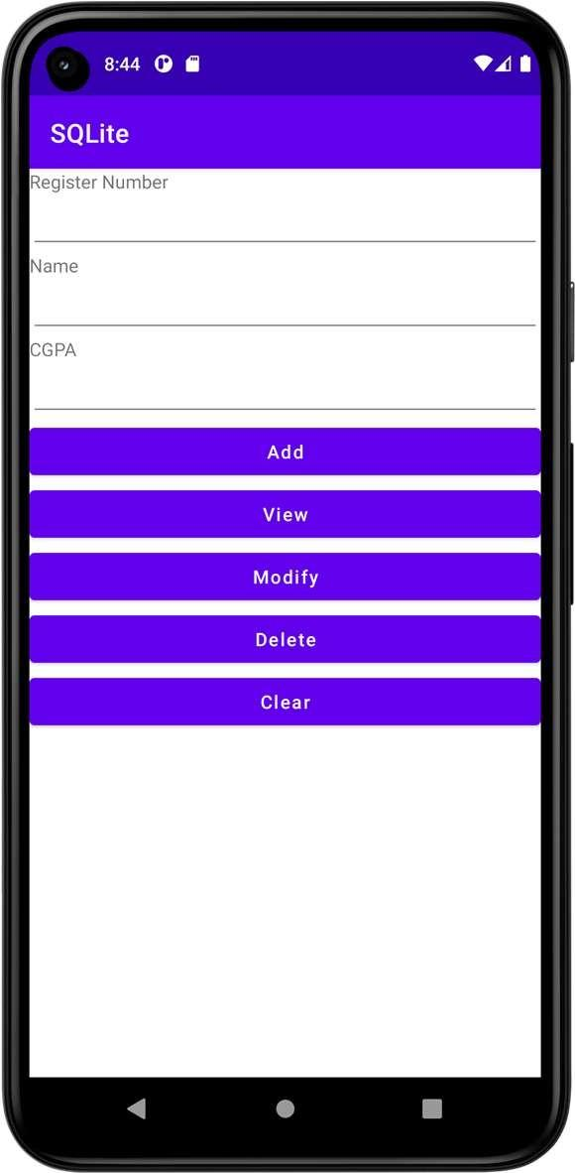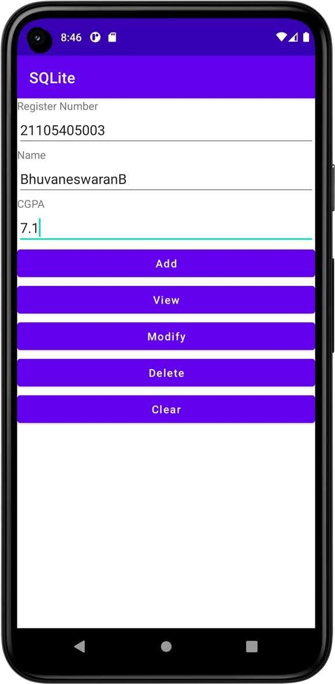

**Dept. of Computer Science and Engineering** | **Rajalakshmi Engineering College**

**Ex. No. : 06 Date : 18/03/2025**

**Register No. : 220701264 Name : SHARAN KUMAR D**

**Form Validation**

**Aim**

Design an android activity with two text boxes where the user can enter (username and ID) and a button (validate). Validate the entered username and ID field for the following using android code. i) Both the fields should not be empty ii) Name field should have alphabets iii) ID field should have numeric values (only 4-digit).

**Procedure**

**Step 1:** Create a New Android Project in Android Studio.  


**Step 2:** Design the Layout with two EditText fields (for username and ID) and a Button (for validation) in the activity_main.xml file.

**Step 3:** Implement the Validation Logic in MainActivity.kt to check if both fields are not empty, validate that the username contains only alphabets, and validate that the ID contains only numeric values and is exactly 4 digits.

**Step 4:** Run the Application: If the validation fails, show a Toast message with an error, and if it succeeds, show a success message.



**Dept. of Computer Science and Engineering** | **Rajalakshmi Engineering College**

**45**

**AndroidManifest.xml**

**46**

*<?***xml version="1.0" encoding="utf-8"***?>*

<**manifest xmlns:android="**[**http://schemas.android.com/apk/res/android**](http://schemas.android.com/apk/res/android)**" xmlns:tools="**[**http://schemas.android.com/tools**](http://schemas.android.com/tools)**"**>

<**application**

**android:allowBackup="true" android:dataExtractionRules="@xml/data_extraction_rules" android:fullBackupContent="@xml/backup_rules" android:icon="@mipmap/ic_launcher" android:label="@string/app_name" android:supportsRtl="true" android:theme="@style/Theme.FormValidation" tools:targetApi="31"**>

<**activity**

**android:name=".MainActivity2" android:exported="false"** />

<**activity**

**android:name=".MainActivity" android:exported="true"**>

<**intent-filter**>

<**action android:name="android.intent.action.MAIN"** />

<**category android:name="android.intent.category.LAUNCHER"** />

</**intent-filter**>

</**activity**>

</**application**>

</**manifest**>

**Dept. of Computer Science and Engineering** | **Rajalakshmi Engineering College**

**activity_main.xml**

*<?***xml version="1.0" encoding="utf-8"***?>*

<**LinearLayout xmlns:android="**[**http://schemas.android.com/apk/res/android**](http://schemas.android.com/apk/res/android)**" xmlns:app="**[**http://schemas.android.com/apk/res-auto**](http://schemas.android.com/apk/res-auto)**" xmlns:tools="**[**http://schemas.android.com/tools**](http://schemas.android.com/tools)**" android:layout_width="match_parent" android:layout_height="match_parent"**

**android:orientation="vertical" tools:context=".MainActivity"**>

<**EditText**

**android:id="@+id/etUserName" android:layout_width="match_parent" android:layout_height="wrap_content" android:ems="10"**

**android:hint="Enter the userame...!" android:inputType="textPersonName"** />

<**EditText**

**android:id="@+id/etPinNumber" android:layout_width="match_parent" android:layout_height="wrap_content" android:ems="10"**

**android:hint="Enter the pin number...!" android:inputType="textPersonName"** />

<**Button**

**android:id="@+id/btLogin" android:layout_width="match_parent" android:layout_height="wrap_content" android:text="Login" android:textAllCaps="false"** />

<**Button**

**android:id="@+id/btClear" android:layout_width="match_parent" android:layout_height="wrap_content" android:text="Clear" android:textAllCaps="false"** />

</**LinearLayout**>



**Dept. of Computer Science and Engineering** | **Rajalakshmi Engineering College**

**47**

**activity_main2.xml**

**48**

*<?***xml version="1.0" encoding="utf-8"***?>*

<**LinearLayout xmlns:android="**[**http://schemas.android.com/apk/res/android**](http://schemas.android.com/apk/res/android)**" xmlns:app="**[**http://schemas.android.com/apk/res-auto**](http://schemas.android.com/apk/res-auto)**" xmlns:tools="**[**http://schemas.android.com/tools**](http://schemas.android.com/tools)**" android:layout_width="match_parent" android:layout_height="match_parent"**

**android:orientation="vertical" tools:context=".MainActivity2"**>

<**TextView**

**android:id="@+id/tvLoginSuccess" android:layout_width="match_parent" android:layout_height="wrap_content" android:text="Login Success...!" android:textAlignment="center" android:textSize="24sp"** />

</**LinearLayout**>

**Dept. of Computer Science and Engineering** | **Rajalakshmi Engineering College**

**MainActivity.kt**

**package** org.rajalakshmi.formvalidation

**import** android.content.Intent

**import** androidx.appcompat.app.AppCompatActivity

**import** android.os.Bundle **import** android.widget.Button **import** android.widget.EditText **import** android.widget.Toast

**class** MainActivity : AppCompatActivity() {

**override fun** onCreate(savedInstanceState: Bundle?) { **super**.onCreate(savedInstanceState) setContentView(R.layout.*activity_main*)

**val** etUserName : EditText = findViewById(R.id.*etUserName*) **val** etPinNumber : EditText = findViewById(R.id.*etPinNumber*) **val** btLogin : Button = findViewById(R.id.*btLogin*)

**val** btClear : Button = findViewById(R.id.*btClear*)

btLogin.setOnClickListener **{**

**val** checkUserName = **"[a-zA-Z]+"**.*toRegex*() **val** checkPinNo = **"[0-9]{4}"**.*toRegex*()

**if**(checkUserName.matches(etUserName.*text*.toString()) && checkPinNo.matches(etPinNumber.*text*.toString())) {

**val** intent = Intent(**this**, MainActivity2::**class**.*java*) startActivity(intent)

}

**else** {

Toast.makeText(*applicationContext*, **"Invalid User Name / Pin No."**,Toast.*LENGTH_LONG*).show()

}

**}**

btClear.setOnClickListener **{** etUserName.*text*.clear() etPinNumber.*text*.clear()

**}**

}

}



**Dept. of Computer Science and Engineering** | **Rajalakshmi Engineering College**

**49**

**MainActivity2.kt**

**50**

**package** org.rajalakshmi.formvalidation

**import** androidx.appcompat.app.AppCompatActivity

**import** android.os.Bundle

**class** MainActivity2 : AppCompatActivity() {

**override fun** onCreate(savedInstanceState: Bundle?) { **super**.onCreate(savedInstanceState) setContentView(R.layout.*activity_main2*)

}

}

**Dept. of Computer Science and Engineering** | **Rajalakshmi Engineering College**

**Output**

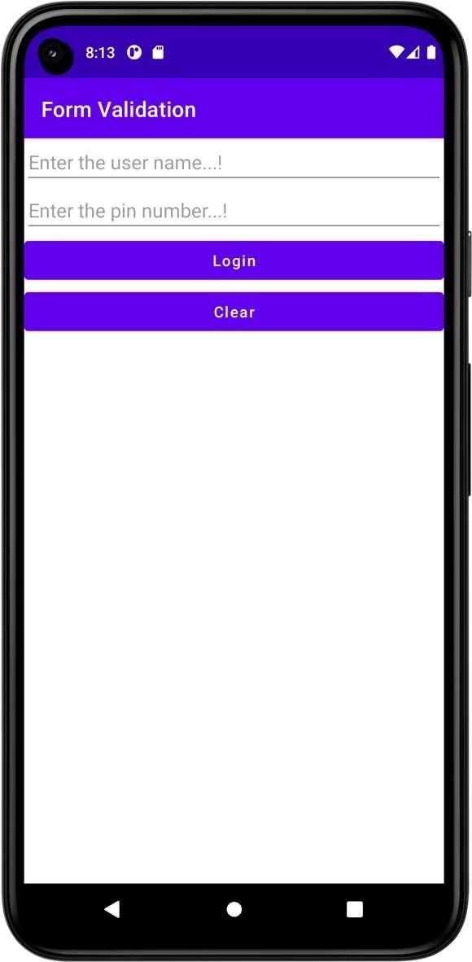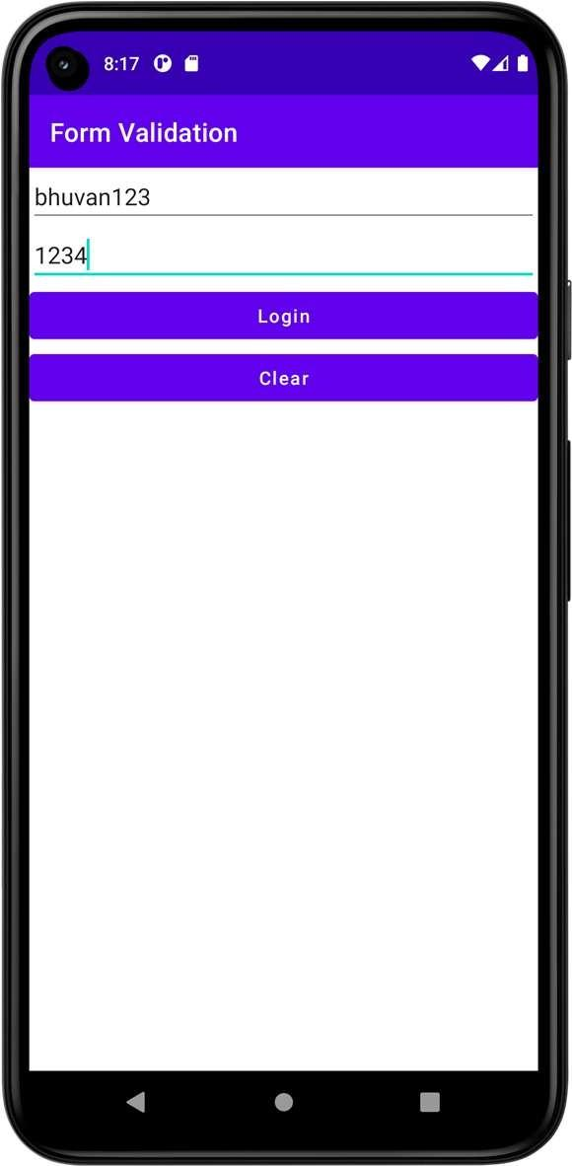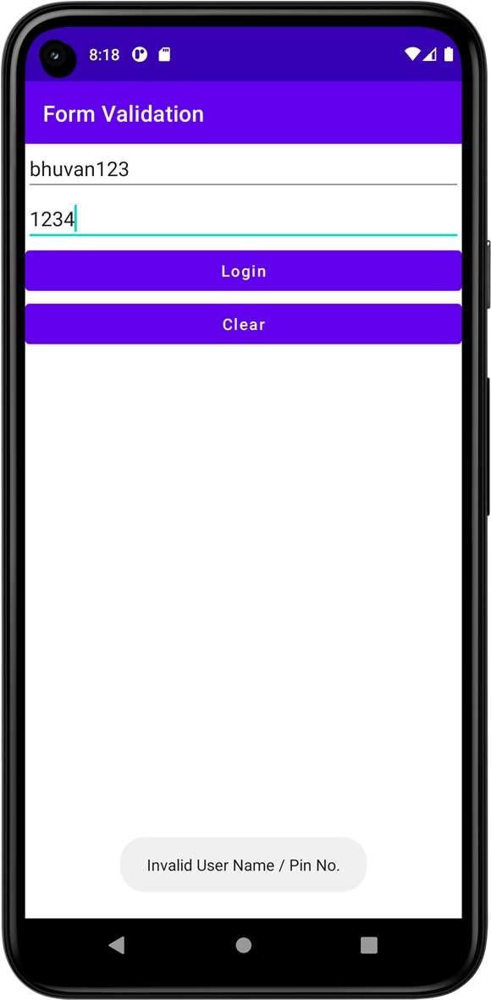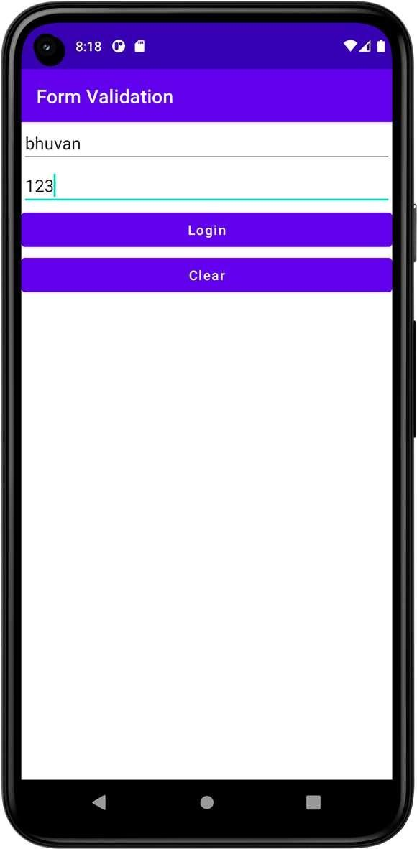



**Dept. of Computer Science and Engineering** | **Rajalakshmi Engineering College**

**51**

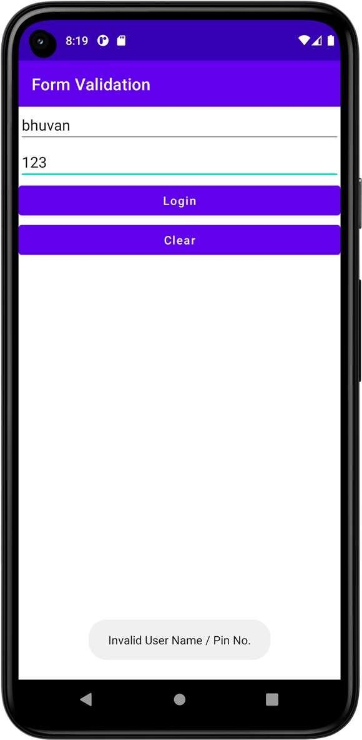 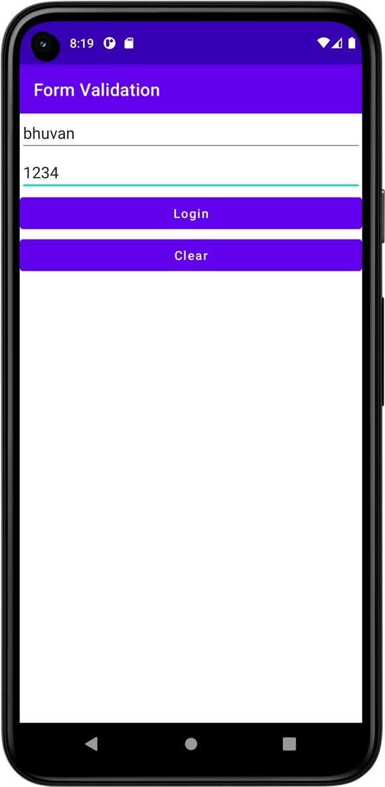

**52**

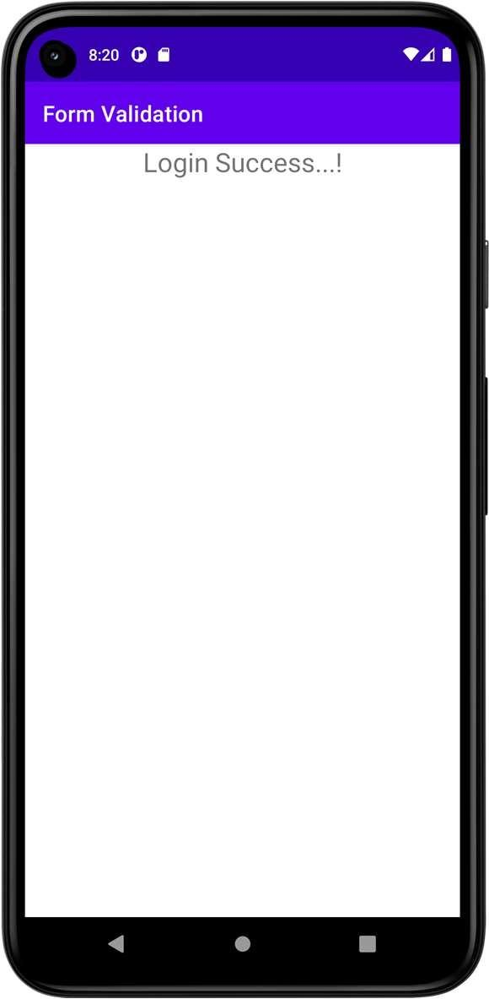

**Result**



**Dept. of Computer Science and Engineering** | **Rajalakshmi Engineering College**

|  |  |  |
| --- | --- | --- |
| **Ex. No. : 07**  **Register No. : 220701264** |  | **Date : 25/03/2025**  **Name : SHARAN KUMAR D** |
| **Aim** |  | **SD Card** |



Implement an application to write the Register Number, Name and CGPA to SD card in text file format.

**Procedure**



**Step 1:** Create a New Android Project in Android Studio**.**

**Step 2:** Add Necessary Permissions in the AndroidManifest.xml to read and write to external storage.

**Step 3:** Design the Layout with EditText fields for Register Number, Name, and CGPA, and a Button to trigger the save action.

**Step 4:** Write Code to Handle Button Click in MainActivity.kt to get values from the input fields and save them to a text file on the SD card.

**Step 5:** Check for Permissions before writing to the SD card, and request them if needed**.**

**Step 6:** Write the Data to a text file on the SD card using FileWriter.

**Step 7:**Test the Application to ensure it saves the data to a text file successfully.



**Dept. of Computer Science and Engineering** | **Rajalakshmi Engineering College**

**53**

**AndroidManifest.xml**

**54**

*<?***xml version="1.0" encoding="utf-8"***?>*

<**manifest xmlns:android="**[**http://schemas.android.com/apk/res/android**](http://schemas.android.com/apk/res/android)**" xmlns:tools="**[**http://schemas.android.com/tools**](http://schemas.android.com/tools)**"**>

<**uses-permission android:name="android.permission.WRITE_EXTERNAL_STORAGE"**/>

<**uses-permission android:name="android.permission.READ_EXTERNAL_STORAGE"**/>

<**application**

**android:allowBackup="true" android:dataExtractionRules="@xml/data_extraction_rules" android:fullBackupContent="@xml/backup_rules" android:icon="@mipmap/ic_launcher" android:label="@string/app_name" android:supportsRtl="true" android:theme="@style/Theme.SDCard" tools:targetApi="31"**>

<**activity**

**android:name=".MainActivity" android:exported="true"**>

<**intent-filter**>

<**action android:name="android.intent.action.MAIN"** />

<**category android:name="android.intent.category.LAUNCHER"** />

</**intent-filter**>

</**activity**>

</**application**>

</**manifest**>

**Dept. of Computer Science and Engineering** | **Rajalakshmi Engineering College**

**activity_main.xml**

*<?***xml version="1.0" encoding="utf-8"***?>*

<**LinearLayout xmlns:android="**[**http://schemas.android.com/apk/res/android**](http://schemas.android.com/apk/res/android)**" xmlns:app="**[**http://schemas.android.com/apk/res-auto**](http://schemas.android.com/apk/res-auto)**" xmlns:tools="**[**http://schemas.android.com/tools**](http://schemas.android.com/tools)**" android:layout_width="match_parent" android:layout_height="match_parent"**

**android:orientation="vertical" tools:context=".MainActivity"**>

<**EditText**

**android:id="@+id/etRegisterNumber" android:layout_width="match_parent" android:layout_height="wrap_content" android:ems="10"**

**android:hint="Enter the register number...!" android:inputType="textPersonName"** />

<**EditText**

**android:id="@+id/etName" android:layout_width="match_parent" android:layout_height="wrap_content" android:ems="10"**

**android:hint="Enter the name...!" android:inputType="textPersonName"** />

<**EditText**

**android:id="@+id/etCGPA" android:layout_width="match_parent" android:layout_height="wrap_content" android:ems="10"**

**android:hint="Enter the CGPA...!" android:inputType="textPersonName"** />

<**Button**

**android:id="@+id/btSave" android:layout_width="match_parent" android:layout_height="wrap_content" android:text="Save" android:textAllCaps="false"** />

<**Button**

**android:id="@+id/btLoad" android:layout_width="match_parent" android:layout_height="wrap_content" android:text="Load" android:textAllCaps="false"** />

</**LinearLayout**>



**Dept. of Computer Science and Engineering** | **Rajalakshmi Engineering College**

**55**

**MainActivity.kt**

**56**

**package** org.rajalakshmi.sdcard

**import** androidx.appcompat.app.AppCompatActivity

**import** android.os.Bundle **import** android.widget.Button **import** android.widget.EditText **import** java.io.*

**class** MainActivity : AppCompatActivity() {

**override fun** onCreate(savedInstanceState: Bundle?) { **super**.onCreate(savedInstanceState) setContentView(R.layout.*activity_main*)

**val** etRegisterNumber : EditText = findViewById(R.id.*etRegisterNumber*)

**val** etName : EditText = findViewById(R.id.*etName*) **val** etCGPA : EditText = findViewById(R.id.*etCGPA*) **val** btSave : Button = findViewById(R.id.*btSave*) **val** btLoad : Button = findViewById(R.id.*btLoad*)

btSave.setOnClickListener **{**

**val** registerNumber = etRegisterNumber.*text*.toString()

**val** name = etName.*text*.toString()

**val** cgpa = etCGPA.*text*.toString()

**val** file = File(getExternalFilesDir(**null**), **"student.txt"**) **val** outputStream = FileOutputStream(file, **false**)

outputStream.write(**"$**registerNumber**,$**name**,$**cgpa**\n"**.*toByteArray*()) outputStream.close()

etRegisterNumber.*text*.clear() etName.*text*.clear() etCGPA.*text*.clear()

**}**

btLoad.setOnClickListener **{**

**val** file = File(getExternalFilesDir(**null**), **"student.txt"**) **val** inputStream = FileInputStream(file)

**val** inputStreamReader = InputStreamReader(inputStream) **val** bufferedReader = BufferedReader(inputStreamReader) **var** line: String

line = bufferedReader.readLine() **val** parts = line.*split*(**","**) etRegisterNumber.setText(parts[0]) etName.setText(parts[1]) etCGPA.setText(parts[2]) inputStream.close()

**}**

}

}

**Dept. of Computer Science and Engineering** | **Rajalakshmi Engineering College**

**Output**

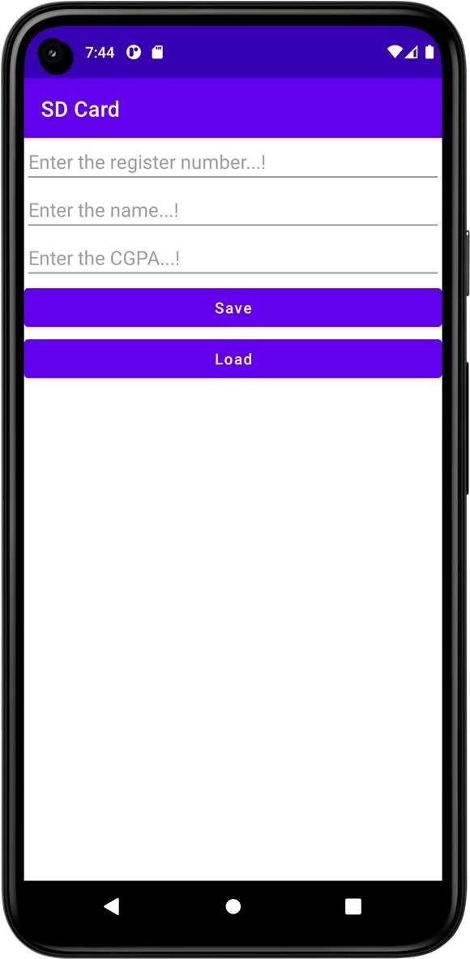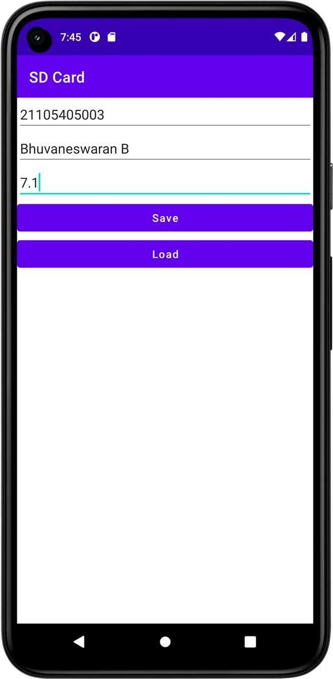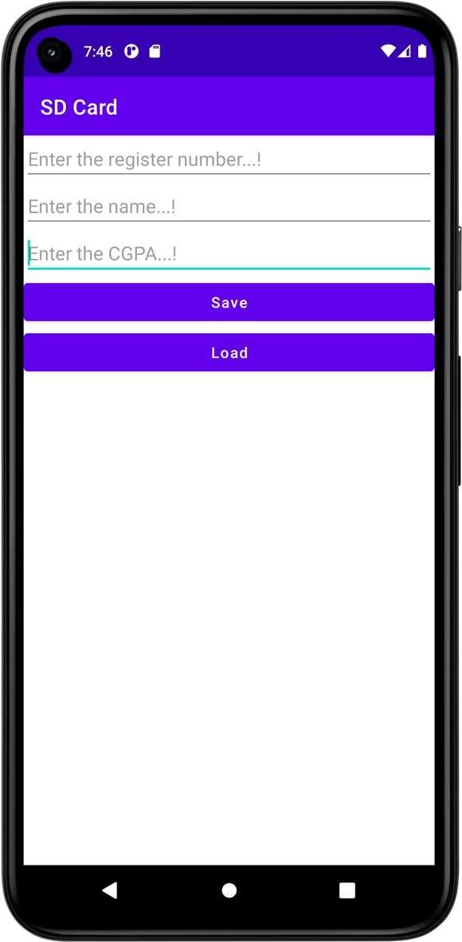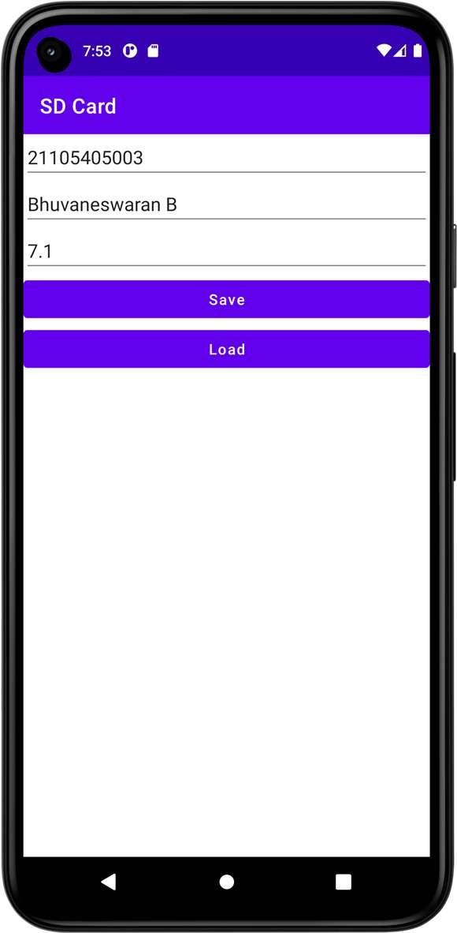

**Result**





**Dept. of Computer Science and Engineering** | **Rajalakshmi Engineering College**

**57**

**Ex. No. : 08 Date : 03/0/2025**

**58**

**Register No. : 220701264 Name : SHARAN KUMAR D**

**Alert Dialog Box**

**Aim**

Implement an application to display the alert box message.

**Procedure**



**Step 1:** Create a New Android Project in Android Studio.

**Step 2:** Design the Layout with a button to trigger the alert box.

**Step 3:** In the MainActivity.kt, set an OnClickListener for the button.

**Step 4:** Use AlertDialog.Builder to create and show the alert dialog with a message.

**Step 5:** Run the Application to ensure the alert box is displayed when the button is clicked.

**AndroidManifest.xml**

*<?***xml version="1.0" encoding="utf-8"***?>*

<**manifest xmlns:android="**[**http://schemas.android.com/apk/res/android**](http://schemas.android.com/apk/res/android)**" xmlns:tools="**[**http://schemas.android.com/tools**](http://schemas.android.com/tools)**"**>

<**application**

**android:allowBackup="true" android:dataExtractionRules="@xml/data_extraction_rules" android:fullBackupContent="@xml/backup_rules" android:icon="@mipmap/ic_launcher" android:label="@string/app_name" android:supportsRtl="true" android:theme="@style/Theme.AlertDialogBox" tools:targetApi="31"**>

<**activity**

**android:name=".MainActivity" android:exported="true"**>

<**intent-filter**>

<**action android:name="android.intent.action.MAIN"** />

<**category android:name="android.intent.category.LAUNCHER"** />

</**intent-filter**>

</**activity**>

</**application**>

</**manifest**>



**Dept. of Computer Science and Engineering** | **Rajalakshmi Engineering College**

**59**

**activity_main.xml**

**60**

*<?***xml version="1.0" encoding="utf-8"***?>*

<**LinearLayout xmlns:android="**[**http://schemas.android.com/apk/res/android**](http://schemas.android.com/apk/res/android)**" xmlns:app="**[**http://schemas.android.com/apk/res-auto**](http://schemas.android.com/apk/res-auto)**" xmlns:tools="**[**http://schemas.android.com/tools**](http://schemas.android.com/tools)**" android:layout_width="match_parent" android:layout_height="match_parent"**

**android:orientation="vertical" tools:context=".MainActivity"**>

<**EditText**

**android:id="@+id/etText" android:layout_width="match_parent" android:layout_height="wrap_content" android:ems="10"**

**android:hint="Enter the text...!" android:inputType="textPersonName"** />

<**Button**

**android:id="@+id/btDisplay" android:layout_width="match_parent" android:layout_height="wrap_content" android:text="Display" android:textAllCaps="false"** />

</**LinearLayout**>

**Dept. of Computer Science and Engineering** | **Rajalakshmi Engineering College**

**MainActivity.kt**

**package** org.rajalakshmi.alertdialogbox

**import** androidx.appcompat.app.AppCompatActivity

**import** android.os.Bundle **import** android.widget.Button **import** android.widget.EditText **import** android.widget.Toast

**import** androidx.appcompat.app.AlertDialog

**class** MainActivity : AppCompatActivity() {

**override fun** onCreate(savedInstanceState: Bundle?) { **super**.onCreate(savedInstanceState) setContentView(R.layout.*activity_main*)

**val** etText : EditText = findViewById(R.id.*etText*)

**val** btDisplay : Button = findViewById(R.id.*btDisplay*)

btDisplay.setOnClickListener **{**

**val** alertDialog = AlertDialog.Builder(**this**)

.setTitle(**"MAD Lab"**)

.setMessage(etText.*text*.toString())

.setPositiveButton(**"OK"**) **{** dialog, which **->**

Toast.makeText(*applicationContext*, **"You clicked OK"**, Toast.*LENGTH_LONG*).show()

**}**

.setNegativeButton(**"Cancel"**) **{** dialog, which **->**

Toast.makeText(*applicationContext*, **"You clicked Cancel"**, Toast.*LENGTH_LONG*).show()

**}**

.create() alertDialog.show()

**}**

}

}



**Dept. of Computer Science and Engineering** | **Rajalakshmi Engineering College**

**61**

**Output**

**62**

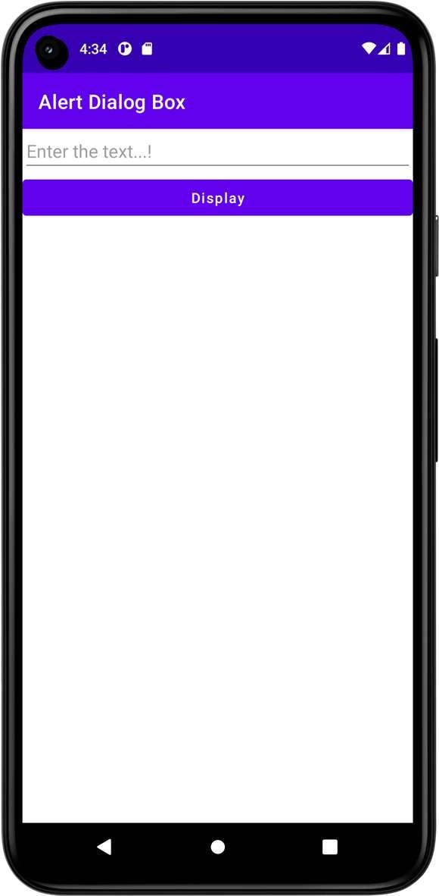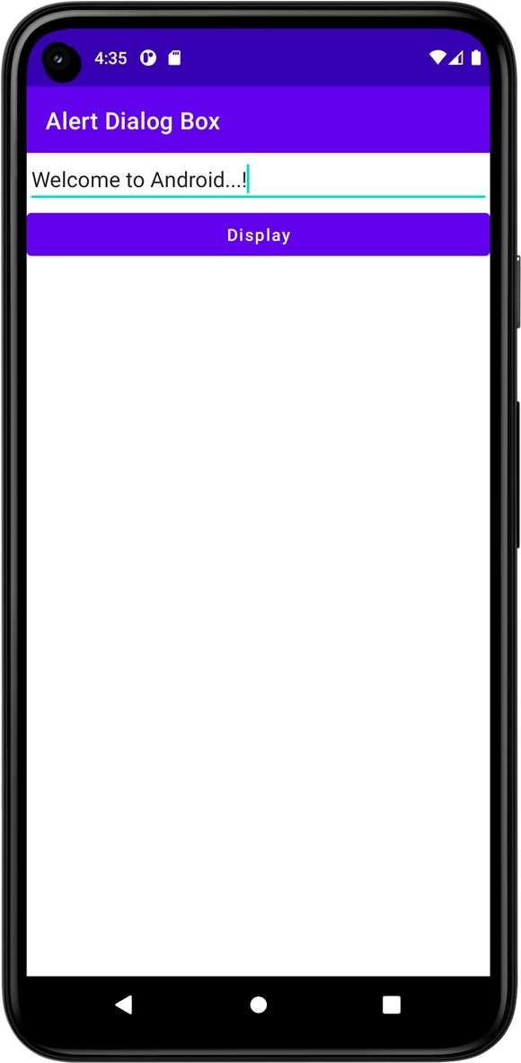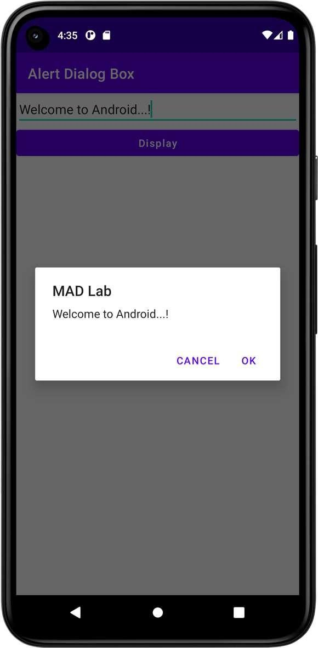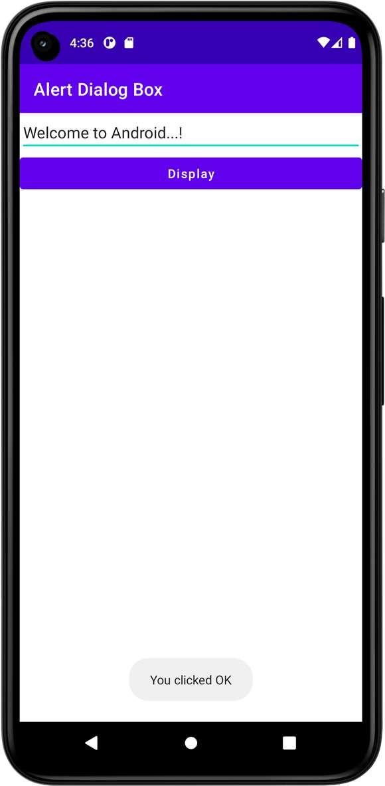

**Dept. of Computer Science and Engineering** | **Rajalakshmi Engineering College**

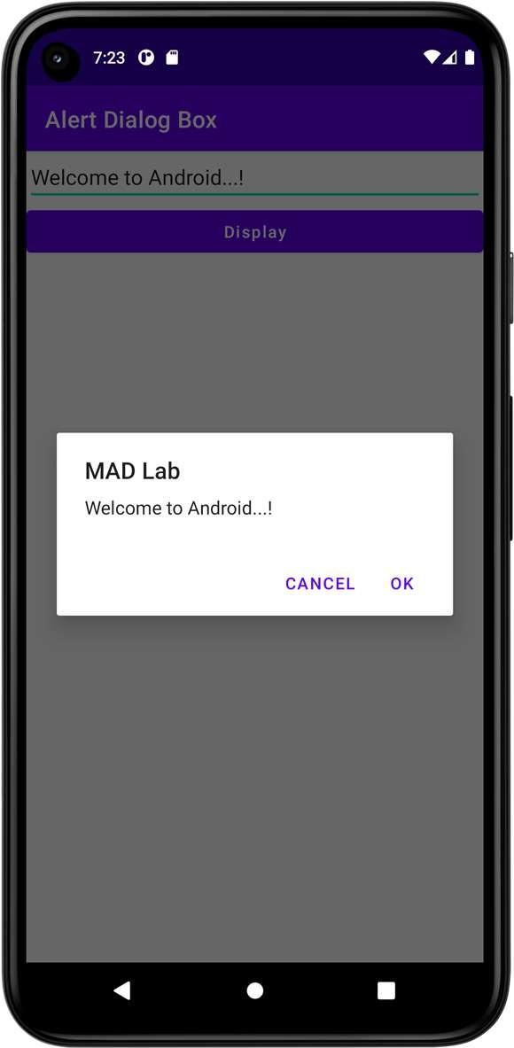 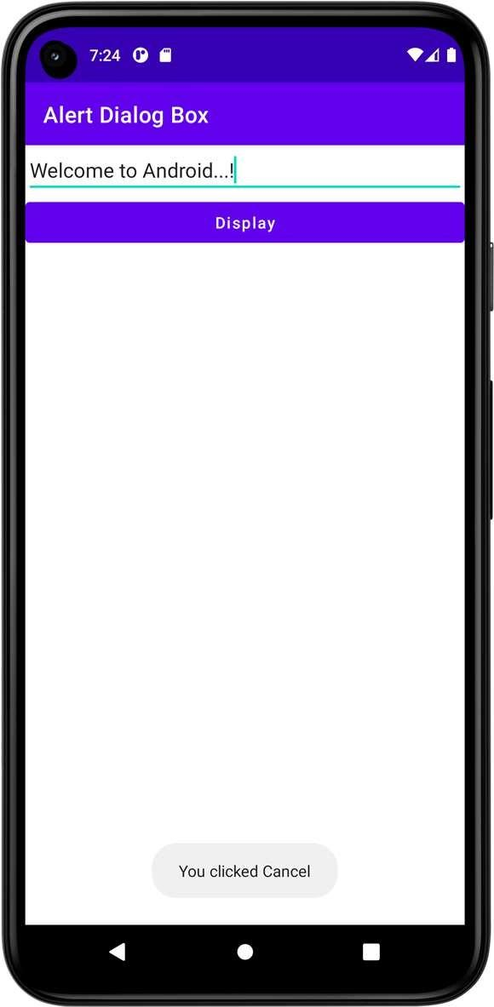

**Result**





**Dept. of Computer Science and Engineering** | **Rajalakshmi Engineering College**

**63**

**Ex. No. : 09 Date : 12/04/2025**

**64**

**Dept. of Computer Science and Engineering** | **Rajalakshmi Engineering College**

**Register No. : 220701264 Name : SHARAN KUMAR D**

**Alarm**

**Aim**

Write a mobile application to set the alarm using android Alarm Manager class.

**Procedure**



**Step1:** Create a New Android Project in Android Studio**.**

**Step 2:** Add Permissions in the AndroidManifest.xml to access the system alarm services.

**Step 3:** Design the Layout with EditText fields to enter the alarm time and a Button to set the alarm.

**Step 4:** Implement Alarm Logic in the MainActivity.kt using AlarmManager to set an alarm at a specific time.

**Step 5:** Handle Alarm Trigger: Create a BroadcastReceiver to handle when the alarm goes off.

**Step 6:** Test the Application to ensure the alarm is set and triggered correctly.

**AndroidManifest.xml**

*<?***xml version="1.0" encoding="utf-8"***?>*

<**manifest xmlns:android="**[**http://schemas.android.com/apk/res/android**](http://schemas.android.com/apk/res/android)**" xmlns:tools="**[**http://schemas.android.com/tools**](http://schemas.android.com/tools)**"**>

<**uses-permission android:name="android.permission.SCHEDULE_EXACT_ALARM"**/>

<**application**

**android:allowBackup="true" android:dataExtractionRules="@xml/data_extraction_rules" android:fullBackupContent="@xml/backup_rules" android:icon="@mipmap/ic_launcher" android:label="@string/app_name" android:supportsRtl="true" android:theme="@style/Theme.MyApplication" tools:targetApi="31"**>

<**activity**

**android:name=".MainActivity" android:exported="true"**>

<**intent-filter**>

<**action android:name="android.intent.action.MAIN"** />

<**category android:name="android.intent.category.LAUNCHER"** />

</**intent-filter**>

</**activity**>

<**receiver android:name=".AlarmReceiver"**>

</**receiver**>

</**application**>

</**manifest**>



**Dept. of Computer Science and Engineering** | **Rajalakshmi Engineering College**

**65**

**activity_main.xml**

**66**

*<?***xml version="1.0" encoding="utf-8"***?>*

<**LinearLayout xmlns:android="**[**http://schemas.android.com/apk/res/android**](http://schemas.android.com/apk/res/android)**" xmlns:app="**[**http://schemas.android.com/apk/res-auto**](http://schemas.android.com/apk/res-auto)**" xmlns:tools="**[**http://schemas.android.com/tools**](http://schemas.android.com/tools)**" android:layout_width="match_parent" android:layout_height="match_parent"**

**android:orientation="vertical" tools:context=".MainActivity"**>

<**TimePicker**

**android:id="@+id/timePicker" android:layout_width="match_parent" android:layout_height="wrap_content" android:layout_gravity="center"** />

<**Button**

**android:id="@+id/btSetAlarm" android:layout_width="match_parent" android:layout_height="wrap_content" android:text="Set Alarm" android:textAllCaps="false"** />

<**Button**

**android:id="@+id/btnStopAlarm" android:layout_width="match_parent" android:layout_height="wrap_content" android:text="Stop Alarm" android:textAllCaps="false"** />

</**LinearLayout**>

**Dept. of Computer Science and Engineering** | **Rajalakshmi Engineering College**

**MainActivity.kt**

**package** org.rajalakshmi.myapplication

**import** android.app.AlarmManager **import** android.app.PendingIntent **import** android.content.Intent

**import** androidx.appcompat.app.AppCompatActivity

**import** android.os.Bundle

**import** android.widget.Button **import** android.widget.TimePicker **import** android.widget.Toast **import** java.util.*

**class** MainActivity : AppCompatActivity() {

**lateinit var pendingIntent**: PendingIntent

**private lateinit var alarmManager**: AlarmManager

**override fun** onCreate(savedInstanceState: Bundle?) { **super**.onCreate(savedInstanceState) setContentView(R.layout.*activity_main*)

**val** alarmTimePicker: TimePicker = findViewById(R.id.*timePicker*)

**val** btSetAlarm : Button = findViewById(R.id.*btSetAlarm*)

**val** btStopAlarm : Button = findViewById(R.id.*btnStopAlarm*)

**alarmManager** = getSystemService(*ALARM_SERVICE*) **as** AlarmManager

btSetAlarm.setOnClickListener **{**

Toast.makeText(*applicationContext*, **"Alarm ON...!"**, Toast.*LENGTH_LONG*).show()

**val** calendar: Calendar = Calendar.getInstance() calendar.set(Calendar.*HOUR_OF_DAY*, alarmTimePicker.*hour*) calendar.set(Calendar.*MINUTE*, alarmTimePicker.*minute*) **val** intent = Intent(**this**, AlarmReceiver::**class**.*java*)

**pendingIntent** = PendingIntent.getBroadcast(**this**.*applicationContext*, 2, intent, PendingIntent.*FLAG_CANCEL_CURRENT*)

**val** time:Long = calendar.*timeInMillis* - (calendar.*timeInMillis* %

60000)

**alarmManager**.setRepeating(AlarmManager.*RTC_WAKEUP*, time, 10000,

**pendingIntent**)

**}**

btStopAlarm.setOnClickListener **{ alarmManager**.cancel(**pendingIntent**) Toast.makeText(*applicationContext*, **"Alarm OFF...!"**,

Toast.*LENGTH_LONG*).show()

**}**

}

}



**Dept. of Computer Science and Engineering** | **Rajalakshmi Engineering College**

**67**

**AlarmReceiver.kt**

**68**

**package** org.rajalakshmi.myapplication

**import** android.content.BroadcastReceiver

**import** android.content.Context **import** android.content.Intent **import** android.media.Ringtone

**import** android.media.RingtoneManager

**import** android.net.Uri

**import** android.widget.Toast

**class** AlarmReceiver : BroadcastReceiver() {

**override fun** onReceive(context: Context?, intent: Intent?) { Toast.makeText(context, **"Alarm Ringing...!"**, Toast.*LENGTH_LONG*).show() **var** ringtone: Ringtone

**val** alarmUri: Uri = RingtoneManager.getDefaultUri(RingtoneManager.*TYPE_ALARM*)

ringtone = RingtoneManager.getRingtone(context, alarmUri) ringtone.play()

}

}

**Dept. of Computer Science and Engineering** | **Rajalakshmi Engineering College**

**Output**

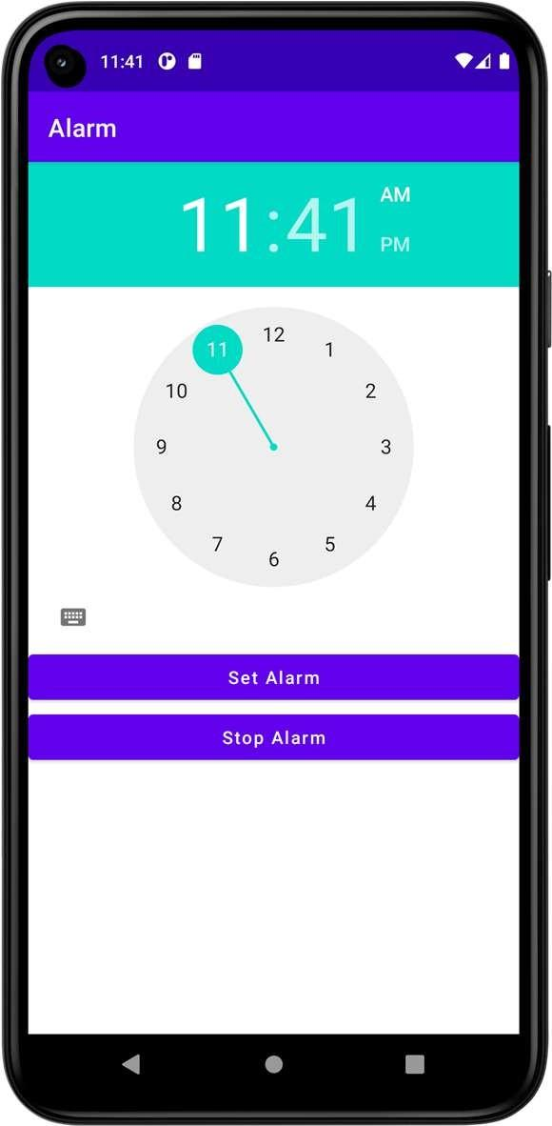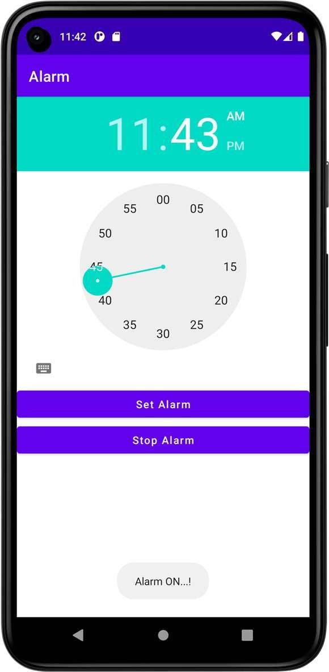

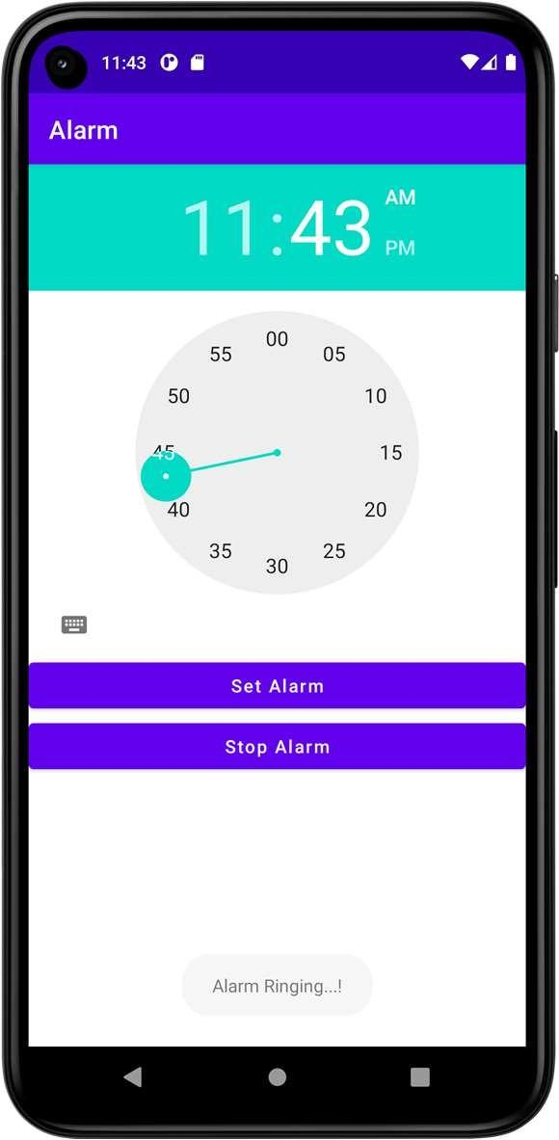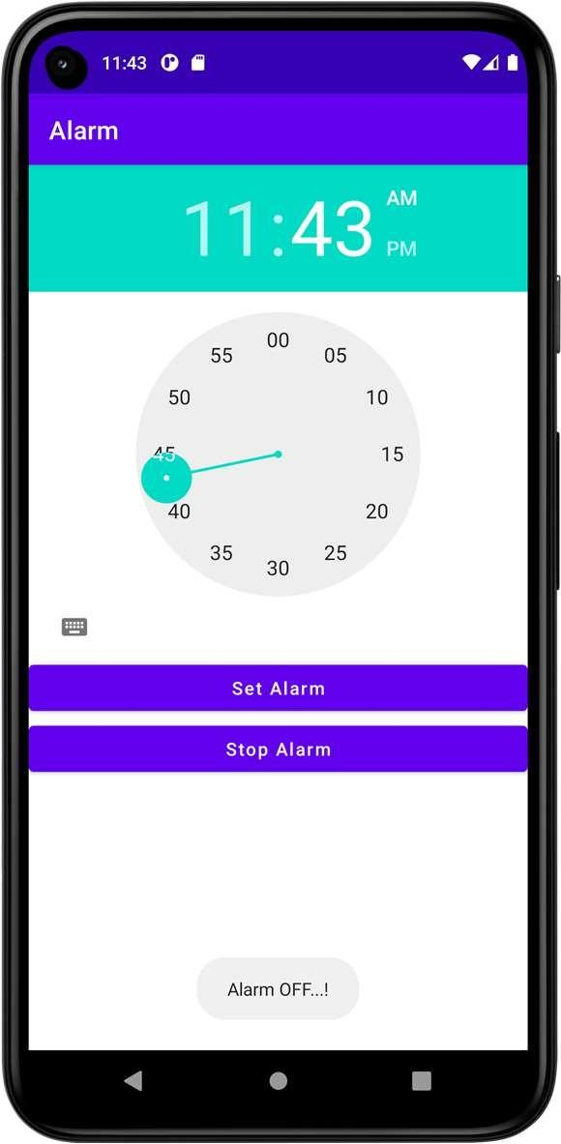



**Dept. of Computer Science and Engineering** | **Rajalakshmi Engineering College**

**69**

**Ex. No. : 10 Date : 12/04/2025**

**70**

**Register No. : 220701264 Name : SHARAN KUMAR D**

**Telephony Services**

**Aim**

Develop an android application to display the information of the telephony services.

**Procedure**



**Step 1:** Create a New Android Project in Android Studio.

**Step 2:** Add Permissions in the AndroidManifest.xml to access telephony services.

**Step 3:** Design the Layout with TextView elements to display the telephony information (phone number, network type, SIM status).

**Step 4:** Use the TelephonyManager to retrieve telephony data in MainActivity.

**Step 5:** Display the Telephony Information on the screen by setting the text of the TextView widgets with the obtained values.

**Step 6:** Test the Application to ensure it correctly retrieves and displays telephony information.

**AndroidManifest.xml**

*<?***xml version="1.0" encoding="utf-8"***?>*

<**manifest xmlns:android="**[**http://schemas.android.com/apk/res/android**](http://schemas.android.com/apk/res/android)**" xmlns:tools="**[**http://schemas.android.com/tools**](http://schemas.android.com/tools)**"**>

<**uses-permission android:name="android.permission.READ_PHONE_STATE"**/>

<**application**

**android:allowBackup="true" android:dataExtractionRules="@xml/data_extraction_rules" android:fullBackupContent="@xml/backup_rules" android:icon="@mipmap/ic_launcher" android:label="@string/app_name" android:supportsRtl="true" android:theme="@style/Theme.TelephonyServices" tools:targetApi="31"**>

<**activity**

**android:name=".MainActivity" android:exported="true"**>

<**intent-filter**>

<**action android:name="android.intent.action.MAIN"** />

<**category android:name="android.intent.category.LAUNCHER"** />

</**intent-filter**>

</**activity**>

</**application**>

</**manifest**>



**Dept. of Computer Science and Engineering** | **Rajalakshmi Engineering College**

**71**

**activity_main.xml**

**72**

*<?***xml version="1.0" encoding="utf-8"***?>*

<**LinearLayout xmlns:android="**[**http://schemas.android.com/apk/res/android**](http://schemas.android.com/apk/res/android)**" xmlns:app="**[**http://schemas.android.com/apk/res-auto**](http://schemas.android.com/apk/res-auto)**" xmlns:tools="**[**http://schemas.android.com/tools**](http://schemas.android.com/tools)**" android:layout_width="match_parent" android:layout_height="match_parent"**

**android:orientation="vertical" tools:context=".MainActivity"**>

<**TextView**

**android:id="@+id/tvNetworkOperatorName" android:layout_width="match_parent" android:layout_height="wrap_content" android:text="Network Operator Name"** />

<**EditText**

**android:id="@+id/etNetworkOperatorName" android:layout_width="match_parent" android:layout_height="wrap_content" android:ems="10" android:inputType="textPersonName"** />

<**TextView**

**android:id="@+id/tvPhoneType" android:layout_width="match_parent" android:layout_height="wrap_content" android:text="Phone Type"** />

<**EditText**

**android:id="@+id/etPhoneType" android:layout_width="match_parent" android:layout_height="wrap_content" android:ems="10" android:inputType="textPersonName"** />

<**TextView**

**android:id="@+id/tvNetworkCountryISO" android:layout_width="match_parent" android:layout_height="wrap_content" android:text="Network Country ISO"** />

<**EditText**

**android:id="@+id/etNetworkCountryISO" android:layout_width="match_parent" android:layout_height="wrap_content" android:ems="10" android:inputType="textPersonName"** />

<**TextView**

**android:id="@+id/tvSIMCountryISO" android:layout_width="match_parent" android:layout_height="wrap_content" android:text="SIM Country ISO"** />

<**EditText**

**android:id="@+id/etSIMCountryISO" android:layout_width="match_parent" android:layout_height="wrap_content" android:ems="10"**

**Dept. of Computer Science and Engineering** | **Rajalakshmi Engineering College**

**android:inputType="textPersonName"** />

<**TextView**

**android:id="@+id/tvDeviceSoftwareVersion" android:layout_width="match_parent" android:layout_height="wrap_content" android:text="Device Software Version"** />

<**EditText**

**android:id="@+id/etDeviceSoftwareVersion" android:layout_width="match_parent" android:layout_height="wrap_content" android:ems="10" android:inputType="textPersonName"** />

<**Button**

**android:id="@+id/btGetTelephonyServices" android:layout_width="match_parent" android:layout_height="wrap_content" android:text="Get Telephony Services" android:textAllCaps="false"** />

</**LinearLayout**>



**Dept. of Computer Science and Engineering** | **Rajalakshmi Engineering College**

**73**

**MainActivity.kt**

**74**

**package** org.rajalakshmi.telephonyservices

**import** android.content.Context

**import** android.content.pm.PackageManager

**import** androidx.appcompat.app.AppCompatActivity

**import** android.os.Bundle

**import** android.telephony.TelephonyManager

**import** android.widget.Button

**import** android.widget.EditText

**import** androidx.core.app.ActivityCompat

**class** MainActivity : AppCompatActivity() {

**private val REQUEST_CODE_PHONE_STATE** = 1000

**override fun** onCreate(savedInstanceState: Bundle?) { **super**.onCreate(savedInstanceState) setContentView(R.layout.*activity_main*)

**val** etNetworkOperatorName : EditText = findViewById(R.id.*etNetworkOperatorName*)

**val** etPhoneType : EditText = findViewById(R.id.*etPhoneType*)

**val** etNetworkCountryISO : EditText = findViewById(R.id.*etNetworkCountryISO*)

**val** etSIMCountryISO : EditText = findViewById(R.id.*etSIMCountryISO*)

**val** etDeviceSoftwareVersion : EditText = findViewById(R.id.*etDeviceSoftwareVersion*)

**val** btGetTelephonyServices : Button = findViewById(R.id.*btGetTelephonyServices*)

**val** telephonyManager = getSystemService(Context.*TELEPHONY_SERVICE*) **as**

TelephonyManager

**if** (ActivityCompat.checkSelfPermission(**this**, android.Manifest.permission.*READ_PHONE_STATE*) != PackageManager.*PERMISSION_GRANTED* ) {

ActivityCompat.requestPermissions(**this**,

*arrayOf*(android.Manifest.permission.*READ_PHONE_STATE*), **REQUEST_CODE_PHONE_STATE**)

}

btGetTelephonyServices.setOnClickListener **{**

**val** networkOperatorName = telephonyManager.*networkOperatorName*

**val** phoneType: Int = telephonyManager.getPhoneType()

**var** strphoneType : String = **"" val** networkCountryISO: String =

telephonyManager.getNetworkCountryIso()

**val** SIMCountryISO: String = telephonyManager.getSimCountryIso()

**val** deviceSoftwareVersion: String? = telephonyManager.getDeviceSoftwareVersion()

**when** (phoneType) {

TelephonyManager.*PHONE_TYPE_CDMA* -> strphoneType = **"CDMA"** TelephonyManager.*PHONE_TYPE_GSM* -> strphoneType = **"GSM"** TelephonyManager.*PHONE_TYPE_NONE* -> strphoneType = **"NONE"**

}

etNetworkOperatorName.setText(networkOperatorName) etPhoneType.setText(strphoneType) etNetworkCountryISO.setText(networkCountryISO) etSIMCountryISO.setText(SIMCountryISO) etDeviceSoftwareVersion.setText(deviceSoftwareVersion)

**}**

}

}

**Dept. of Computer Science and Engineering** | **Rajalakshmi Engineering College**

**Output**

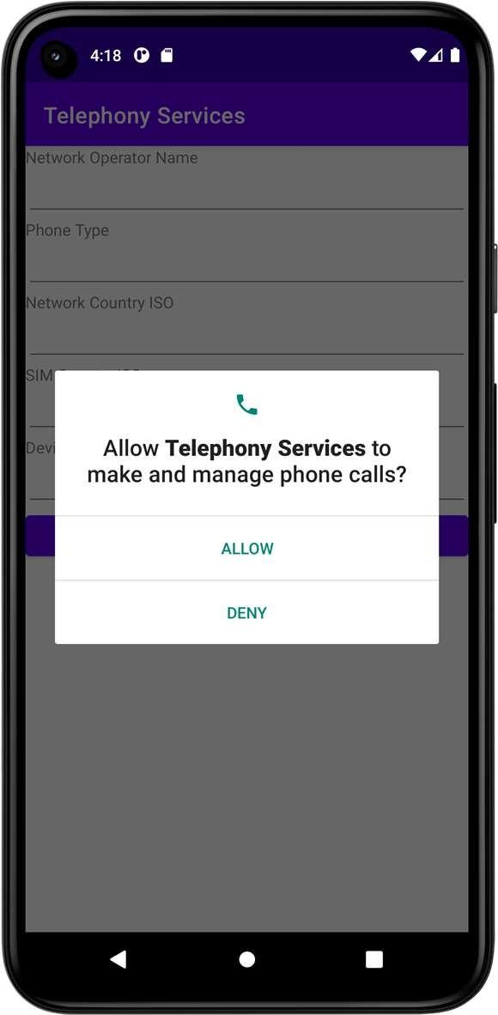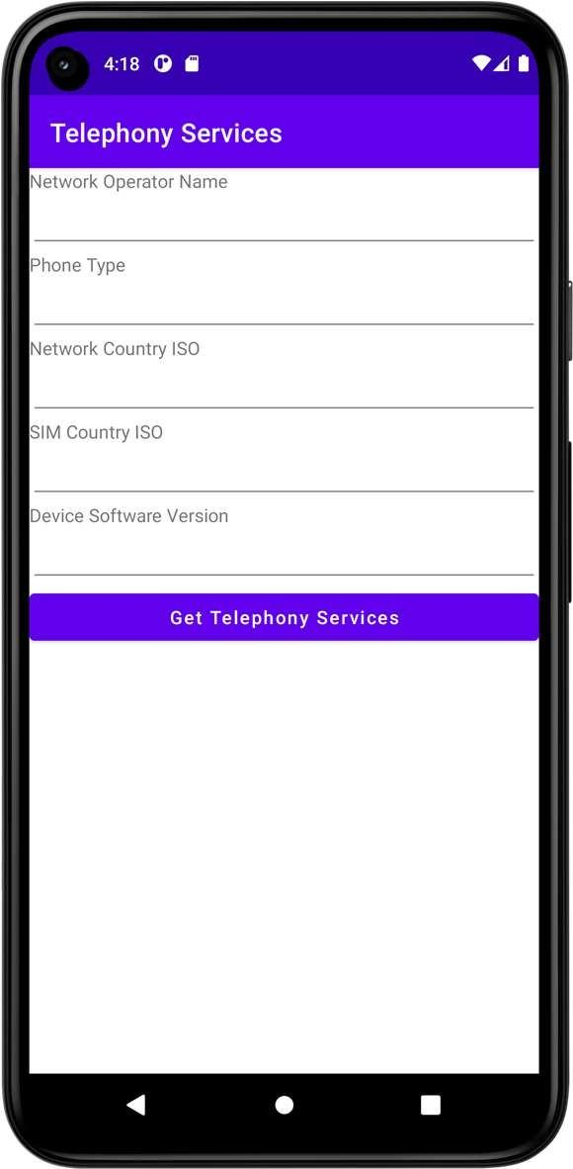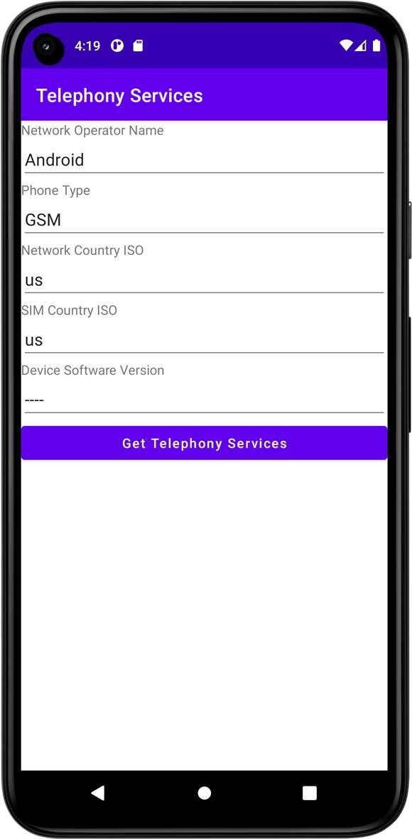

**Result**





**Dept. of Computer Science and Engineering** | **Rajalakshmi Engineering College**

**75**

|  |  |  |
| --- | --- | --- |
| **Ex. No. :**  **Register No. : 220701264** | **11** | **Date : 12/04/2025**  **Name : SHARAN KUMAR D** |
| **Aim** |  | **Send SMS** |

**76**

Develop an application to send SMS.

**Procedure**



**Step 1:** Create a New Android Project in Android Studio.

**Step 2:** Add Permissions in the AndroidManifest.xml file to allow the app to send SMS.

**Step 3:** Design the Layout with EditText for the phone number and message, and a Button to trigger the SMS sending.

**Step 4:** Handle Button Click in the MainActivity to send the SMS.

**Step 5:** Test the Application to ensure SMS is sent correctly.

**AndroidManifest.xml**

*<?***xml version="1.0" encoding="utf-8"***?>*

<**manifest xmlns:android="**[**http://schemas.android.com/apk/res/android**](http://schemas.android.com/apk/res/android)**" xmlns:tools="**[**http://schemas.android.com/tools**](http://schemas.android.com/tools)**"**>

<**uses-permission android:name="android.permission.SEND_SMS"**/>

<**application**

**android:allowBackup="true" android:dataExtractionRules="@xml/data_extraction_rules" android:fullBackupContent="@xml/backup_rules" android:icon="@mipmap/ic_launcher" android:label="@string/app_name" android:supportsRtl="true" android:theme="@style/Theme.SendSMS" tools:targetApi="31"**>

<**activity**

**android:name=".MainActivity" android:exported="true"**>

<**intent-filter**>

<**action android:name="android.intent.action.MAIN"** />

<**category android:name="android.intent.category.LAUNCHER"** />

</**intent-filter**>

</**activity**>

</**application**>

</**manifest**>



**Dept. of Computer Science and Engineering** | **Rajalakshmi Engineering College**

**77**

**activity_main.xml**

**78**

*<?***xml version="1.0" encoding="utf-8"***?>*

<**LinearLayout xmlns:android="**[**http://schemas.android.com/apk/res/android**](http://schemas.android.com/apk/res/android)**" xmlns:app="**[**http://schemas.android.com/apk/res-auto**](http://schemas.android.com/apk/res-auto)**" xmlns:tools="**[**http://schemas.android.com/tools**](http://schemas.android.com/tools)**" android:layout_width="match_parent" android:layout_height="match_parent"**

**android:orientation="vertical" tools:context=".MainActivity"**>

<**EditText**

**android:id="@+id/etPhoneNumber" android:layout_width="match_parent" android:layout_height="wrap_content" android:ems="10"**

**android:hint="Enter the phone number...!" android:inputType="textPersonName"** />

<**EditText**

**android:id="@+id/etMessage" android:layout_width="match_parent" android:layout_height="wrap_content" android:ems="10"**

**android:hint="Enter the message...!" android:inputType="textPersonName"** />

<**Button**

**android:id="@+id/btSend" android:layout_width="match_parent" android:layout_height="wrap_content" android:text="Send" android:textAllCaps="false"** />

</**LinearLayout**>

**Dept. of Computer Science and Engineering** | **Rajalakshmi Engineering College**

**MainActivity.kt**

**package** org.rajalakshmi.sendsms

**import** android.os.Build

**import** androidx.appcompat.app.AppCompatActivity

**import** android.os.Bundle

**import** android.telephony.SmsManager

**import** android.widget.Button **import** android.widget.EditText **import** android.widget.Toast

**import** androidx.core.app.ActivityCompat

**class** MainActivity : AppCompatActivity() {

**override fun** onCreate(savedInstanceState: Bundle?) { **super**.onCreate(savedInstanceState) setContentView(R.layout.*activity_main*)

**val** etPhoneNumber : EditText = findViewById(R.id.*etPhoneNumber*)

**val** etMessage : EditText = findViewById(R.id.*etMessage*) **val** btSend : Button = findViewById(R.id.*btSend*) ActivityCompat.requestPermissions(**this**,

*arrayOf*(android.Manifest.permission.*SEND_SMS*),1000)

btSend.setOnClickListener **{**

**val** phoneNumber = etPhoneNumber.*text*.toString()

**val** message = etMessage.*text*.toString()

**val** smsManager: SmsManager smsManager = SmsManager.getDefault()

smsManager.sendTextMessage(phoneNumber, **null**, message, **null**, **null**) Toast.makeText(*applicationContext*, **"Message Sent"**,

Toast.*LENGTH_LONG*).show()

**}**

}

}



**Dept. of Computer Science and Engineering** | **Rajalakshmi Engineering College**

**79**

**Output**

**80**

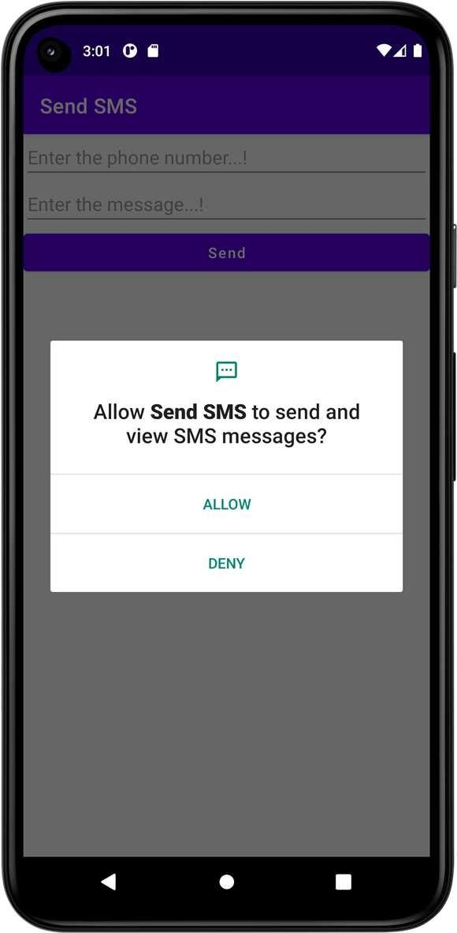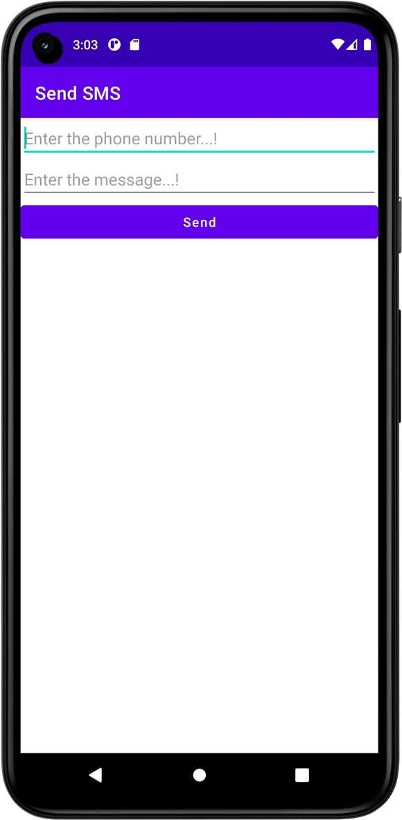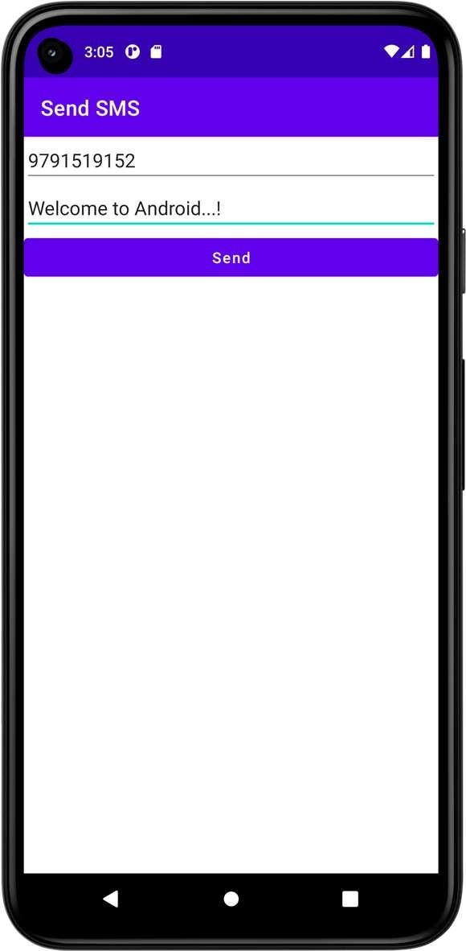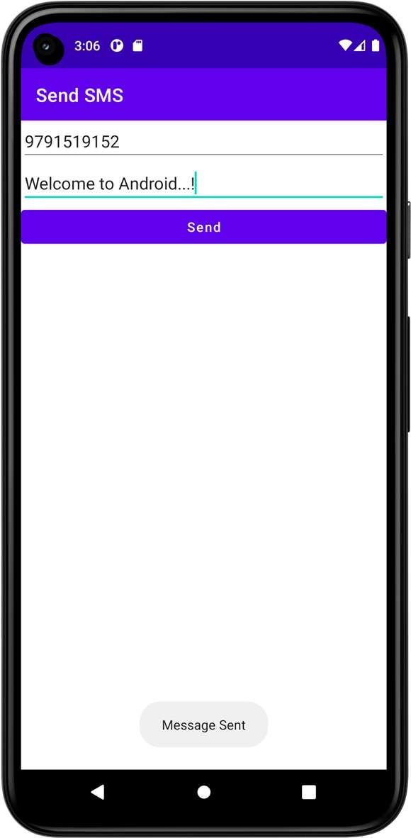

**Result**



**Dept. of Computer Science and Engineering** | **Rajalakshmi Engineering College**

|  |  |  |
| --- | --- | --- |
| **Ex. No. :**  **Register No. : 220701264** | **12** | **Date : 12/04/2025**  **Name : SHARAN KUMAR D** |
| **Aim** |  | **Send Email** |



Develop an application to send Email.

**Procedure**



**Step 1:** Create a new Android project in Android Studio.

**Step 2:** Design the layout with fields for recipient email, subject, and message, and add a "Send Email" button.

**Step 3:** Implement the email sending logic in the MainActivity using an implicit intent with action Intent.ACTION_SENDTO**.**

**Step 4:** Use a mailto: URI to ensure the email app is launched.

**Step 5:** Run the app and test by sending an email using the default email client on the device.



**Dept. of Computer Science and Engineering** | **Rajalakshmi Engineering College**

**81**

**AndroidManifest.xml**

**82**

*<?***xml version="1.0" encoding="utf-8"***?>*

<**manifest xmlns:android="**[**http://schemas.android.com/apk/res/android**](http://schemas.android.com/apk/res/android)**" xmlns:tools="**[**http://schemas.android.com/tools**](http://schemas.android.com/tools)**"**>

<**application**

**android:allowBackup="true" android:dataExtractionRules="@xml/data_extraction_rules" android:fullBackupContent="@xml/backup_rules" android:icon="@mipmap/ic_launcher" android:label="@string/app_name" android:supportsRtl="true" android:theme="@style/Theme.SendEmail" tools:targetApi="31"**>

<**activity**

**android:name=".MainActivity" android:exported="true"**>

<**intent-filter**>

<**action android:name="android.intent.action.MAIN"** />

<**category android:name="android.intent.category.LAUNCHER"** />

</**intent-filter**>

</**activity**>

</**application**>

</**manifest**>

**Dept. of Computer Science and Engineering** | **Rajalakshmi Engineering College**

**activity_main.xml**

*<?***xml version="1.0" encoding="utf-8"***?>*

<**LinearLayout xmlns:android="**[**http://schemas.android.com/apk/res/android**](http://schemas.android.com/apk/res/android)**" xmlns:app="**[**http://schemas.android.com/apk/res-auto**](http://schemas.android.com/apk/res-auto)**" xmlns:tools="**[**http://schemas.android.com/tools**](http://schemas.android.com/tools)**" android:layout_width="match_parent" android:layout_height="match_parent"**

**android:orientation="vertical" tools:context=".MainActivity"**>

<**TextView**

**android:id="@+id/tvEmail" android:layout_width="match_parent" android:layout_height="wrap_content" android:text="To"** />

<**EditText**

**android:id="@+id/etEmail" android:layout_width="match_parent" android:layout_height="wrap_content" android:ems="10" android:inputType="textPersonName"** />

<**TextView**

**android:id="@+id/tvSubject" android:layout_width="match_parent" android:layout_height="wrap_content" android:text="Subject"** />

<**EditText**

**android:id="@+id/etSubject" android:layout_width="match_parent" android:layout_height="wrap_content" android:ems="10" android:inputType="textPersonName"** />

<**TextView**

**android:id="@+id/tvMessage" android:layout_width="match_parent" android:layout_height="wrap_content" android:text="Message"** />

<**EditText**

**android:id="@+id/etMessage" android:layout_width="match_parent" android:layout_height="wrap_content" android:ems="10" android:inputType="textPersonName"** />

<**Button**

**android:id="@+id/btSend" android:layout_width="match_parent" android:layout_height="wrap_content" android:text="Send" android:textAllCaps="false"** />

</**LinearLayout**>



**Dept. of Computer Science and Engineering** | **Rajalakshmi Engineering College**

**83**

**MainActivity.kt**

**84**

**package** org.rajalakshmi.sendemail

**import** android.content.Intent

**import** androidx.appcompat.app.AppCompatActivity

**import** android.os.Bundle **import** android.widget.Button **import** android.widget.EditText **import** android.widget.TextView

**class** MainActivity : AppCompatActivity() {

**override fun** onCreate(savedInstanceState: Bundle?) { **super**.onCreate(savedInstanceState) setContentView(R.layout.*activity_main*)

**val** etEmail : EditText = findViewById(R.id.*etEmail*)

**val** etSubject : EditText = findViewById(R.id.*etSubject*) **val** etMessage : EditText = findViewById(R.id.*etMessage*) **val** btSend : Button = findViewById([R.id](http://r.id).*btSend*)

btSend.setOnClickListener {

val email = etEmail.text.toString()

val subject = etSubject.text.toString()

val message = etMessage.text.toString()

val intent = Intent(Intent.ACTION_SEND) intent.putExtra(Intent.EXTRA_EMAIL, arrayOf(email)) intent.putExtra(Intent.EXTRA_SUBJECT, subject) intent.putExtra(Intent.EXTRA_TEXT, message) intent.type = "message/rfc822" startActivity(Intent.createChooser(intent, "Choose an Email client :"))

}

}

}

**Dept. of Computer Science and Engineering** | **Rajalakshmi Engineering College**

**Output**

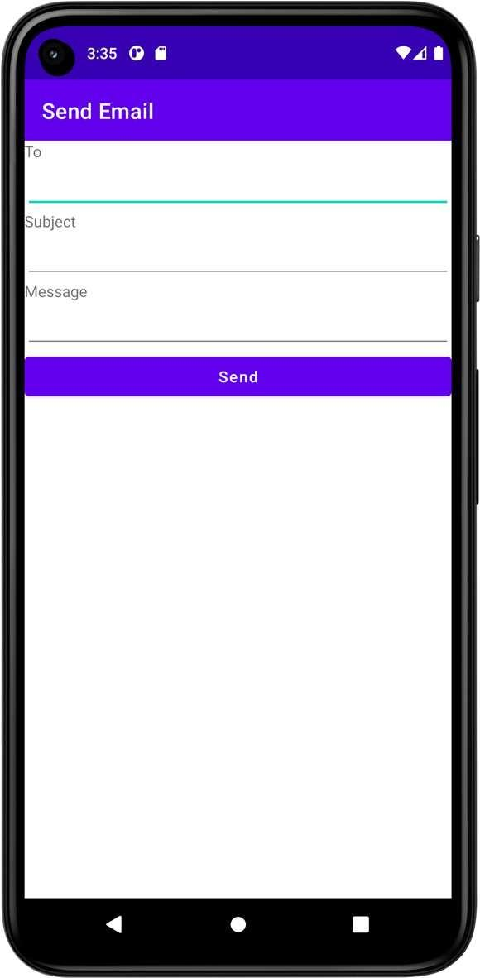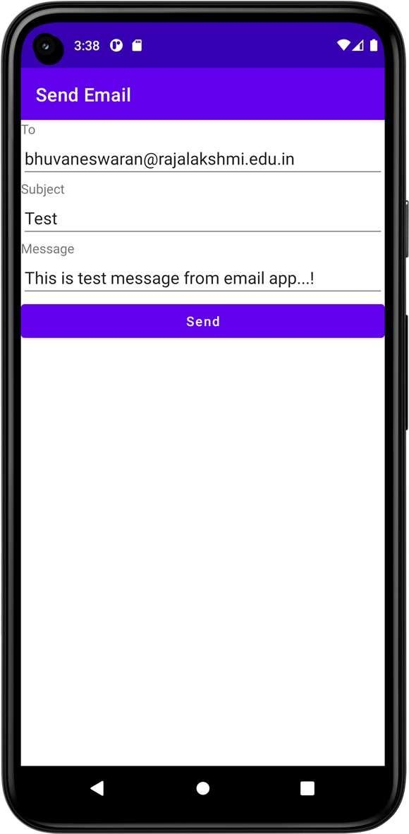

**Result**





**Dept. of Computer Science and Engineering** | **Rajalakshmi Engineering College**

**85**

**Ex. No. : 13 Date : 14/04/2025**

**86**

**Register No. : 220701264 Name : SHARAN KUMAR D**

**Text to Speech**

**Aim**

Develop an android application to perform Text to Speech.

**Procedure**



**Step 1:** Create a new Android project in Android Studio.

**Step 2:** Design the layout with an EditText for input and a Button to trigger speech.

**Step 3:** Initialize the TextToSpeech engine in the MainActivity.

**Step 4:** Handle the button click to convert the entered text to speech.

**Step 5:** Release the TextToSpeech resources in the onDestroy() method.

**Dept. of Computer Science and Engineering** | **Rajalakshmi Engineering College**

**AndroidManifest.xml**

*<?***xml version="1.0" encoding="utf-8"***?>*

<**manifest xmlns:android="**[**http://schemas.android.com/apk/res/android**](http://schemas.android.com/apk/res/android)**" xmlns:tools="**[**http://schemas.android.com/tools**](http://schemas.android.com/tools)**"**>

<**application**

**android:allowBackup="true" android:dataExtractionRules="@xml/data_extraction_rules" android:fullBackupContent="@xml/backup_rules" android:icon="@mipmap/ic_launcher" android:label="@string/app_name" android:supportsRtl="true" android:theme="@style/Theme.TextToSpeech" tools:targetApi="31"**>

<**activity**

**android:name=".MainActivity" android:exported="true"**>

<**intent-filter**>

<**action android:name="android.intent.action.MAIN"** />

<**category android:name="android.intent.category.LAUNCHER"** />

</**intent-filter**>

</**activity**>

</**application**>

</**manifest**>



**Dept. of Computer Science and Engineering** | **Rajalakshmi Engineering College**

**87**

**activity_main.xml**

**88**

*<?***xml version="1.0" encoding="utf-8"***?>*

<**LinearLayout xmlns:android="**[**http://schemas.android.com/apk/res/android**](http://schemas.android.com/apk/res/android)**" xmlns:app="**[**http://schemas.android.com/apk/res-auto**](http://schemas.android.com/apk/res-auto)**" xmlns:tools="**[**http://schemas.android.com/tools**](http://schemas.android.com/tools)**" android:layout_width="match_parent" android:layout_height="match_parent"**

**android:orientation="vertical" tools:context=".MainActivity"**>

<**EditText**

**android:id="@+id/etText" android:layout_width="match_parent" android:layout_height="wrap_content" android:ems="10"**

**android:hint="Enter the text..!" android:inputType="textPersonName" android:textSize="24sp"** />

<**Button**

**android:id="@+id/btSpeak" android:layout_width="match_parent" android:layout_height="wrap_content" android:text="Speak" android:textAllCaps="false" android:textSize="24sp"** />

</**LinearLayout**>

**Dept. of Computer Science and Engineering** | **Rajalakshmi Engineering College**

**MainActivity.kt**

**package** org.rajalakshmi.texttospeech

**import** androidx.appcompat.app.AppCompatActivity

**import** android.os.Bundle

**import** android.speech.tts.TextToSpeech

**import** android.widget.Button **import** android.widget.EditText **import** android.widget.Toast **import** java.util.*

**class** MainActivity : AppCompatActivity(), TextToSpeech.OnInitListener {

**lateinit var tts** : TextToSpeech

**lateinit var btSpeak** : Button

**override fun** onCreate(savedInstanceState: Bundle?) { **super**.onCreate(savedInstanceState) setContentView(R.layout.*activity_main*)

**val** etText : EditText = findViewById(R.id.*etText*) **btSpeak** = findViewById(R.id.*btSpeak*) **btSpeak**.*isEnabled* = **false**

**tts** = TextToSpeech(**this**, **this**)

**btSpeak**.setOnClickListener **{**

**val** text = etText!!.*text*.toString()

**tts**!!.speak(text, TextToSpeech.*QUEUE_FLUSH*, **null**,**""**)

**}**

}

**override fun** onInit(status: Int) {

**if** (status == TextToSpeech.*SUCCESS*) {

**val** result = **tts**!!.setLanguage(Locale.*US*)

**if** (result == TextToSpeech.*LANG_MISSING_DATA* || result == TextToSpeech.*LANG_NOT_SUPPORTED*) {

Toast.makeText(*applicationContext*, **"The Language not**

**supported...!"**, Toast.*LENGTH_LONG*).show()

}

**else** {

**btSpeak**!!.*isEnabled* = **true**

}

}

}

}



**Dept. of Computer Science and Engineering** | **Rajalakshmi Engineering College**

**89**

**Output**

**90**

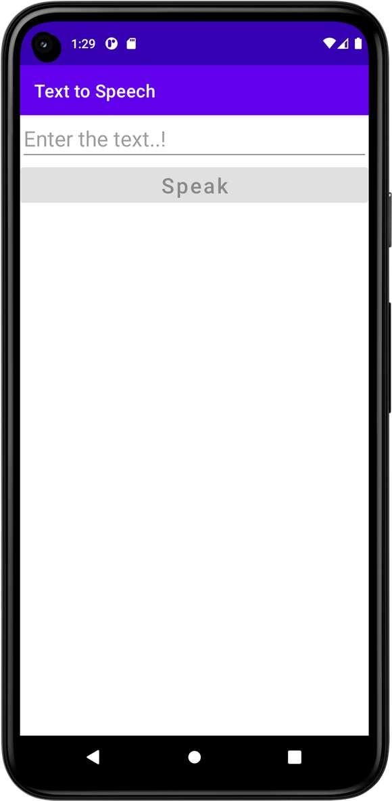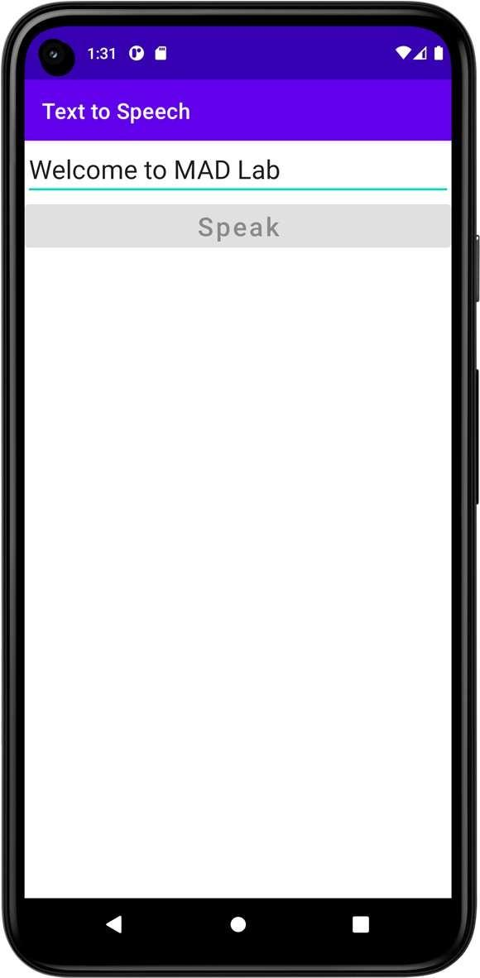

**Result**



**Dept. of Computer Science and Engineering** | **Rajalakshmi Engineering College**

**Ex. No. : 14 Date : 14/04/2025**

**Register No. : 220701264 Name : SHARAN KUMAR D**

**Speech to Text**

**Aim**

Develop an android application to perform Speech to Text.

**Procedure**



**Step 1:** Create a new Android project in Android Studio.

**Step 2:** Design the layout with a Button to start voice input and a TextView to display the recognized text.

**Step 3:** Use Intent.ACTION_RECOGNIZE_SPEECH to launch the speech recognizer.

**Step 4:** Capture the result in onActivityResult and display the recognized speech in the TextView.

**Step 5:** Handle microphone permission for devices running Android 6.0 and above.



**Dept. of Computer Science and Engineering** | **Rajalakshmi Engineering College**

**91**

**AndroidManifest.xml**

**92**

*<?***xml version="1.0" encoding="utf-8"***?>*

<**manifest xmlns:android="**[**http://schemas.android.com/apk/res/android**](http://schemas.android.com/apk/res/android)**" xmlns:tools="**[**http://schemas.android.com/tools**](http://schemas.android.com/tools)**"**>

<**application**

**android:allowBackup="true" android:dataExtractionRules="@xml/data_extraction_rules" android:fullBackupContent="@xml/backup_rules" android:icon="@mipmap/ic_launcher" android:label="@string/app_name" android:supportsRtl="true" android:theme="@style/Theme.SpeechToText" tools:targetApi="31"**>

<**activity**

**android:name=".MainActivity" android:exported="true"**>

<**intent-filter**>

<**action android:name="android.intent.action.MAIN"** />

<**category android:name="android.intent.category.LAUNCHER"** />

</**intent-filter**>

</**activity**>

</**application**>

</**manifest**>

**Dept. of Computer Science and Engineering** | **Rajalakshmi Engineering College**

**activity_main.xml**

*<?***xml version="1.0" encoding="utf-8"***?>*

<**LinearLayout xmlns:android="**[**http://schemas.android.com/apk/res/android**](http://schemas.android.com/apk/res/android)**" xmlns:app="**[**http://schemas.android.com/apk/res-auto**](http://schemas.android.com/apk/res-auto)**" xmlns:tools="**[**http://schemas.android.com/tools**](http://schemas.android.com/tools)**" android:layout_width="match_parent" android:layout_height="match_parent"**

**android:orientation="vertical" tools:context=".MainActivity"**>

<**ImageView**

**android:id="@+id/imgMic" android:layout_width="match_parent" android:layout_height="250dp" app:srcCompat="@android:drawable/ic_btn_speak_now"** />

<**TextView**

**android:id="@+id/tvText" android:layout_width="match_parent" android:layout_height="wrap_content" android:text="Output appears here...!" android:textSize="24sp"** />

</**LinearLayout**>



**Dept. of Computer Science and Engineering** | **Rajalakshmi Engineering College**

**93**

**MainActivity.kt**

**94**

**package** org.rajalakshmi.speechtotext

**import** android.content.Intent

**import** androidx.appcompat.app.AppCompatActivity

**import** android.os.Bundle

**import** android.speech.RecognizerIntent

**import** android.widget.ImageView **import** android.widget.TextView **import** java.util.*

**class** MainActivity : AppCompatActivity() {

**lateinit var tvText** : TextView

**private val REQUEST_CODE_SPEECH_INPUT** = 1000

**override fun** onCreate(savedInstanceState: Bundle?) { **super**.onCreate(savedInstanceState) setContentView(R.layout.*activity_main*)

**var** imgMic : ImageView = findViewById(R.id.*imgMic*) **tvText** = findViewById(R.id.*tvText*) imgMic.setOnClickListener **{**

**val** intent = Intent(RecognizerIntent.*ACTION_RECOGNIZE_SPEECH*) intent.putExtra(RecognizerIntent.*EXTRA_LANGUAGE_MODEL*,

RecognizerIntent.*LANGUAGE_MODEL_FREE_FORM*) intent.putExtra(RecognizerIntent.*EXTRA_LANGUAGE*,

Locale.getDefault())

intent.putExtra(RecognizerIntent.*EXTRA_PROMPT*, **"Speak...!"**) startActivityForResult(intent, **REQUEST_CODE_SPEECH_INPUT**)

**}**

}

**override fun** onActivityResult(requestCode: Int, resultCode: Int, data: Intent?) {

**super**.onActivityResult(requestCode, resultCode, data)

**if**(requestCode == **REQUEST_CODE_SPEECH_INPUT** && resultCode == *RESULT_OK*

&& data != **null**) {

**var** res : ArrayList<String> = data.getStringArrayListExtra(RecognizerIntent.*EXTRA_RESULTS*) **as** ArrayList<String>

**tvText**.setText( Objects.requireNonNull(res)[0])

}

}

}

**Dept. of Computer Science and Engineering** | **Rajalakshmi Engineering College**

**Output**

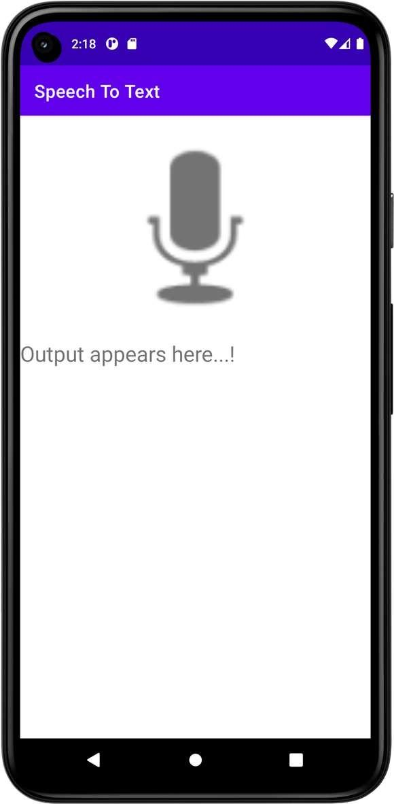

**Result**





**Dept. of Computer Science and Engineering** | **Rajalakshmi Engineering College**

**95**

**Ex. No. : 15 Date : 14/04/2025**

**96**

**Register No. : 220701264 Name : SHARAN KUMAR D**

**Image Capture**

**Aim**

Develop an android application to capture image using camera and displaying the image using ImageView.

**Procedure**



**Step 1:** Create a new Android project in Android Studio.

**Step 2:** Add the camera permission to the AndroidManifest.xml file.

**Step 3:** Design the layout with a Button to open the camera and an ImageView to display the image.

**Step 4:** Use an Intent with MediaStore.ACTION_IMAGE_CAPTURE to launch the camera.

**Step 5 :** Handle the captured image in onActivityResult and display it in the ImageView.

**AndroidManifest.xml**

*<?***xml version="1.0" encoding="utf-8"***?>*

<**manifest xmlns:android="**[**http://schemas.android.com/apk/res/android**](http://schemas.android.com/apk/res/android)**" xmlns:tools="**[**http://schemas.android.com/tools**](http://schemas.android.com/tools)**"**>

<**application**

**android:allowBackup="true" android:dataExtractionRules="@xml/data_extraction_rules" android:fullBackupContent="@xml/backup_rules" android:icon="@mipmap/ic_launcher" android:label="@string/app_name" android:supportsRtl="true" android:theme="@style/Theme.ImageCapture" tools:targetApi="31"**>

<**activity**

**android:name=".MainActivity" android:exported="true"**>

<**intent-filter**>

<**action android:name="android.intent.action.MAIN"** />

<**category android:name="android.intent.category.LAUNCHER"** />

</**intent-filter**>

</**activity**>

</**application**>

</**manifest**>



**Dept. of Computer Science and Engineering** | **Rajalakshmi Engineering College**

**97**

**activity_main.xml**

**98**

*<?***xml version="1.0" encoding="utf-8"***?>*

<**LinearLayout xmlns:android="**[**http://schemas.android.com/apk/res/android**](http://schemas.android.com/apk/res/android)**" xmlns:app="**[**http://schemas.android.com/apk/res-auto**](http://schemas.android.com/apk/res-auto)**" xmlns:tools="**[**http://schemas.android.com/tools**](http://schemas.android.com/tools)**" android:layout_width="match_parent" android:layout_height="match_parent"**

**android:orientation="vertical" tools:context=".MainActivity"**>

<**ImageView**

**android:id="@+id/imgImage" android:layout_width="match_parent" android:layout_height="500dp" app:srcCompat="@android:drawable/ic_menu_camera"** />

<**Button**

**android:id="@+id/btTakePicture" android:layout_width="match_parent" android:layout_height="wrap_content" android:inputType="textCapWords" android:text="Take Picture"** />

</**LinearLayout**>

**Dept. of Computer Science and Engineering** | **Rajalakshmi Engineering College**

**MainActivity.kt**

**package** org.rajalakshmi.imagecapture

**import** android.content.Intent

**import** android.graphics.Bitmap

**import** androidx.appcompat.app.AppCompatActivity

**import** android.os.Bundle

**import** android.provider.MediaStore **import** android.widget.Button **import** android.widget.ImageView

**class** MainActivity : AppCompatActivity() {

**lateinit var imgImage** : ImageView

**private val REQUEST_CODE_IMAGE_CAPTURE** = 1000

**override fun** onCreate(savedInstanceState: Bundle?) { **super**.onCreate(savedInstanceState) setContentView(R.layout.*activity_main*)

**imgImage** = findViewById(R.id.*imgImage*)

**val** btTakePicture : Button = findViewById(R.id.*btTakePicture*)

btTakePicture.setOnClickListener **{**

**val** intent = Intent(MediaStore.*ACTION_IMAGE_CAPTURE*) startActivityForResult(intent, **REQUEST_CODE_IMAGE_CAPTURE**)

**}**

}

**override fun** onActivityResult(requestCode: Int, resultCode: Int, data: Intent?) {

**super**.onActivityResult(requestCode, resultCode, data)

**if**(requestCode == **REQUEST_CODE_IMAGE_CAPTURE** && resultCode == *RESULT_OK*)

{

**val** photo = data!!.*extras*!![**"data"**] **as** Bitmap?

**imgImage**.setImageBitmap(photo)

}

}

}



**Dept. of Computer Science and Engineering** | **Rajalakshmi Engineering College**

**99**

**Output**

**100**

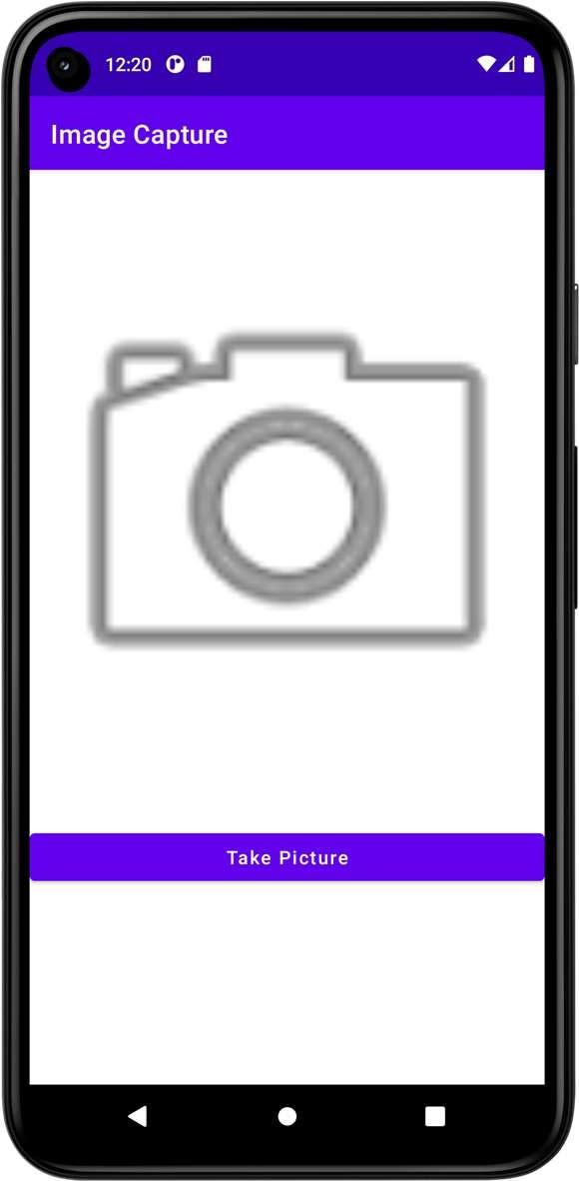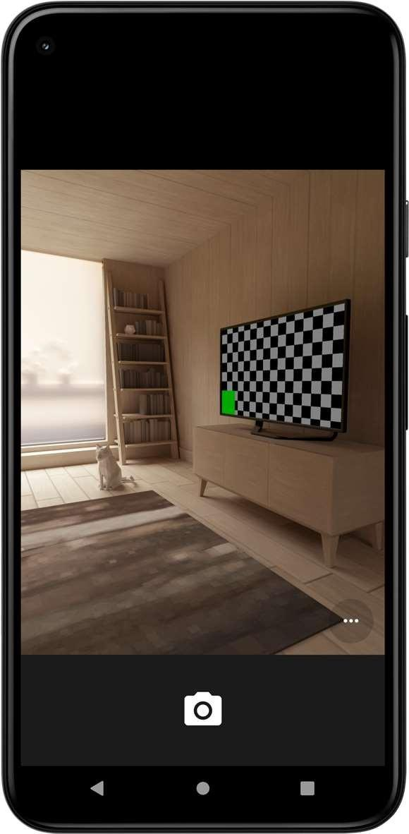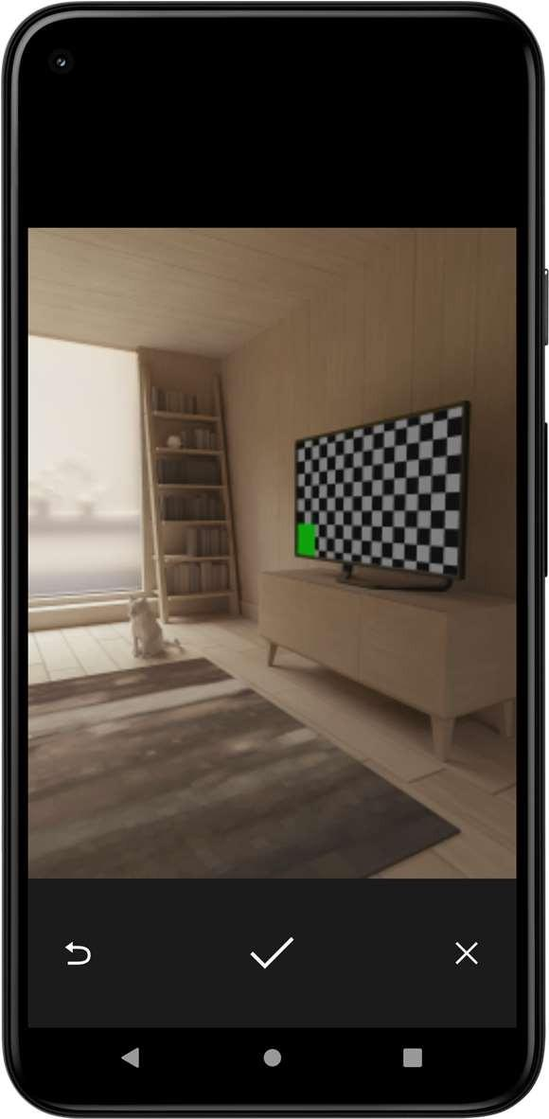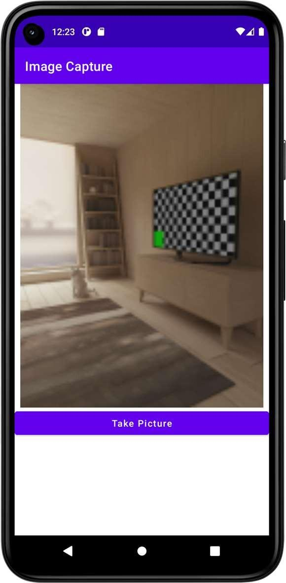

**Result**



**Dept. of Computer Science and Engineering** | **Rajalakshmi Engineering College**